**Supplementary information**

**Automatic Strain Sensor Design *via* Active Learning and Data Augmentation for Soft Machines**

Haitao Yang,‡a Jiali Li,‡a Kai Zhuo Lim,a Chuanji Pan,a Tien Van Truong,b Qian Wang,a Kerui Li,a Shuo Li,a Meng Ding,a Xiaoli Liu,a Qian Xie,c Pablo Valdivia y Alvarado,b Xiaonan Wang,a* Po-Yen Chena*

a Department of Chemical and Biomolecular Engineering, National University of Singapore, 4 Engineering Drive 4, Singapore 117585, Singapore.

b Engineering Product Development, Singapore University of Technology and Design, 8 Somapah Road, Singapore 487372.

c School of Metallurgic Engineering, Anhui University of Technology, 59 Hudong Road, Ma’anshan, P.R. China 243002.

‡ These authors contribute equally to this work.

* Email: [chewxia@nus.edu.sg](mailto:chewxia@nus.edu.sg) (X. Wang); [checp@nus.edu.sg](mailto:checp@nus.edu.sg) (P.-Y. Chen)

This PDF file includes:

**Experimental Section**

**Note S1** to **S12**

**Fig. S1** to **Fig. S13**

**Table S1** to **S9**

**Supplementary Video 1** and **Video 2**

|  |  |  |
| --- | --- | --- |
| Experimental Section | | S4-S7 |
|  | | |
| Note S1 | Different fracture mechanisms observed in *G0*, *G1*-1D, and *G1*-2D sensors under uniaxial strains | S8 |
| Note S2 | Estimated number of experiments required to build a four-DOF dataset for automatic sensor design | S8 |
| Note S3 | Training of a support-vector machine (SVM) classifier | S9 |
| Note S4 | Terms used in active learning loops | S10 |
| Note S5 | Calculation of *A Score* acquisition function | S10–S11 |
| Note S6 | Comparison of various navigation models using different acquisition functions | S11-S12 |
| Note S7 | Construction of an ultimate prediction model through data augmentation and genetic algorithm selection | S12-S13 |
| Note S8 | Implementation of statistical analyses based on Pearson’s coefficients in Python | S13 |
| Note S9 | Automatic strain sensor design | S14 |
| Note S10 | Implementation of *A Score*-based active learning loops in Python | S14 |
| Note S11 | Implementation of variance-based active learning loops in Python | S14 |
| Note S12 | Implementation of random suggestion-based active learning loops in Python | S15 |
|  | | |
| Fig. S1 | Characterizations of Ti3C2Tx MXene nanosheets and SWNTs. | S16 |
| Fig. S2 | Characterizations of ps-MXene layers | S17–S18 |
| Fig. S3 | Fabrication of *G0* sensor and characterizations of planar ps-MXene layer | S19 |
| Fig. S4 | Fabrication of *G1*-1D sensor and characterizations of wrinkle-textured ps-MXene layer | S20 |
| Fig. S5 | Fabrication of *G1*-2D sensor and characterizations of crumple-textured ps-MXene layer | S21 |
| Fig. S6 | Measurement of strain sensing performance of *G0*, *G1*-1D, and *G*1-2D sensors | S22 |
| Fig. S7 | SEM images of *G0*, *G1*-1D, and *G1*-2D sensors under various uniaxial strains | S23 |
| Fig. S8 | Evolution of a preliminary navigation model after first loop of active learning | S24 |
| Fig. S9 | Prediction performance of a trained navigation model on *G*0, *G*1-1D, and *G*1-2D sensors | S25 |
| Fig. S10 | Configuration of a soft pneumatic gripper | S26 |
| Fig. S11 | Stability test of Sensor #1 under repeated uniaxial strains to 26% | S27 |
| Fig. S12 | Resistance–strain profiles of five *G0* sensors (i.e., Sensor #2) embedded within multiple locations of a soft swimmer robot | S28 |
| Fig. S13 | Sensing stability of model-suggested *G0* sensor (i.e., Sensor #2) embedded within multiple locations of a soft swimmer robot under different flapping frequencies | S29 |
|  | | |
| Table S1 | Feasibility grades of delaminating ps-MXene layers from PVDF membranes | S30–S35 |
| Table S2 | 125 data points collected from 12 loops of active learning for navigation model construction | S36–S40 |
| Table S3 | 30 test data for evaluation of ML model’s prediction accuracy | S41–S42 |
| Table S4 | Fabrication recipes with small changes of fabrication parameters resulted in nearly the same sensor characteristics. | S43 |
| Table S5 | Prediction performance of an ultimate prediction model (after UIP method and GA selection) using 30 test data. | S44–S45 |
| Table S6 | Recipe labels suggested by an ultimate prediction model for a soft gripper. | S46 |
| Table S7 | Recipe labels suggested by an ultimate prediction model for a soft swimmer robot. | S47 |
| Table S8 | Suggestion of targeted data points from a variance-based navigation model. | S48 |
| Table S9 | Suggestion of targeted data points from a random suggestion-based navigation model. | S49 |
|  | | |
| Supplementary Video 1 | A soft swimmer robot with model-suggested strain sensors for underwater exploration mission | S50 |
| Supplementary Video 2 | Real-time monitoring of a soft swimmer robot. | S50 |
|  | | |
| Supporting References | | S51 |
|  | |  |

**Experimental Section**

**Preparation of Ti3C2Tx MXene nanosheets**. Ti3C2Tx MXene nanosheets were prepared according to the literature.1 1.0 g of LiF was added to 6.0 M HCl solution (20 mL) under vigorous stirring. After the dissolution of LiF, 1.0 g of Ti3AlC2 MAX powder was slowly added into the HF-containing solution, and then the mixture was kept at 35 °C for 24 hours. Afterwards, the solid residue was washed with deionized water several times until the pH value increased to ca. 7.0. Subsequently, the washed residue was added into 100 mL of deionized water, ultrasonicated for 1 hour under N2 atmosphere, and centrifuged at 3,000 r.p.m. for 30 minutes. The supernatant was collected as the suspension of Ti3C2Tx MXene nanosheets with an approximate concentration of 5 mg mL–1.

**Preparation of single-walled carbon nanotube (SWNT) dispersion**. The SWNT dispersion was obtained by adding SWNT powders into the SDS solution with a concentration of 2 mg mL–1 (at a mass ratio of SWNT:SDS = 1:20). The mixture was then ultrasonicated by a probe sonicator for 2 hours, and the concentration of final SWNT dispersion was about 0.1 mg mL–1.

**Preparation of poly(vinyl alcohol) (PVA) solution***.* 150 mg of PVA was dissolved in 30 mL of deionized water to obtain the PVA solution of 5 mg mL–1, and the concentration of PVA solution was then adjusted to 0.05 mg mL–1 for further use.

**Deposition of ps-MXene layers**. The mixtures of MXene/SWNT/PVA were prepared by mixing the MXene and SWNT dispersions and the PVA solution at various mass ratios, and the mixtures were then deposited on polyvinylidene fluoride (PVDF) membranes (0.22 µm pore, Merck Millipore) through a vacuum-assisted filtration system. After the deposition of MXene/SWNT/PVA mixtures on PVDF membranes, the planar ps-MXene layers were rinsed with excessive deionized water to remove sodium dodecyl sulfate (SDS). The ps-MXene layers were further detached from PVDF membranes by immersing them in an ethanol bath, and the detached ps-MXene layers were stored in ethanol for the fabrication of *Gn* sensors afterwards. The composition of ps-MXene layer was managed to be controlled by tuning the volume ratio of MXene, SWNT, and PVA dispersions/solution, and the thickness of ps-MXene layer was tuned by adjusting the areal mass loading during vacuum-assisted filtration.

**Fabrication of *G0* sensors.** A freestanding ps-MXene layer was carefully transferred onto a VHB tape in an ethanol bath followed by overnight drying. Copper wires were then connected to two ends of planar ps-MXene layer, and silver paste was applied at the connection joints to ensure good electrical contacts.

**Fabrication of *G1*-1D sensors.** Thermally responsive polystyrene (PS) substrate (also called shrink film) with uniaxial pre-strain was first cut into rectangles (with the dimensions of 4 × 8 cm2), washed with ethanol, and dried under nitrogen gas flow. The cut shrink films were next treated with oxygen plasma for 2 minutes to produce hydroxyl groups on the PS surface, which enhanced the hydrophilic interactions between PS substrate and ps-MXene layer.2 Afterwards, the planar ps-MXene layer was carefully transferred onto the plasma-treated shrink film followed by overnight drying. The ps-MXene-coated PS device was heated in an oven at 100 °C for 2.5 minutes to induce uniaxial shrinkage. Afterwards, the shrunk sample was immersed in dichloromethane (DCM) to dissolve the PS substrate to obtain a freestanding ps-MXene layer with wrinkle-like textures, which was sequentially rinsed with DCM, acetone, and ethanol. The wrinkle-textured ps-MXene layers were stored in ethanol and carefully transferred onto a VHB tape followed by overnight drying for the fabrication of *G1*-1D sensors.Copper wires were connected to two ends of wrinkle-textured ps-MXene layer, and silver paste was applied at the connection joints to ensure good electrical contacts.

**Fabrication of *G1***-**2D sensors.** Shrink film with biaxial pre-strain was first cut into rectangles (with the dimensions of 4 × 8 cm2), washed with ethanol, dried under nitrogen gas flow, and treated with oxygen plasma. The planar ps-MXene layer was then carefully transferred onto the plasma-treated shrink film followed by overnight drying. Afterward, the planar ps-MXene-coated PS device was heated in an oven at 100 °C for 5 minutes without constraints for biaxial shrinkage. The shrunk sample was then immersed in DCM to dissolve the PS substrate to obtain a freestanding ps-MXene layer with crumple-like textures, which was sequentially rinsed with DCM, acetone, and ethanol. The crumple-textured ps-MXene layers were stored in ethanol and carefully transferred onto a VHB tape followed by overnight drying for the fabrication of *G1*-2D sensors.Copper wires were connected to two ends of crumple-textured ps-MXene layer, and silver paste was applied at the connection joints to ensure good electrical contacts.

**Fabrication of a soft gripper and integration of model-suggested *Gn* sensors.** A soft gripper was constructed by multiple bellows-type soft actuators, which were made of thermoplastic elastomers shaped from 3D-printed molds. Detailed fabrication steps of the soft gripper used in this work was described in our previous publication.3 In brief, each bellows-type soft actuator consisted of one air channel, which was inflated upon pressurization for bending. The robotic actuation of soft gripper was programmably controlled by a microcontroller (Arduino, Italy) coupled with a pneumatic pump-valve system (Parker, USA). Upon positive gas pressure, the soft gripper was pneumatically inflated and bent along the long axis of its soft robotic body. Three soft actuators acted similar as human fingers to grasp objects, and higher positive gas pressure led to larger degrees of bending. As shown in **Fig. 6a**, the soft gripper was required to grasp two different objects (candle and superglue), and the uniaxial strain changes of grasping candleand superglue were quantified by using *ImageJ* to be 19% and 28%, respectively. According to the estimated strain changes, the ultimate prediction model suggested several feasible fabrication recipes for *Gn* sensors. Model-suggested *Gn* sensors were fabricated and attached onto the exterior surface of one soft actuator. During the robotic tasks, the resistance changes of model-suggested *Gn* sensor were monitored in real time using an electrochemical workstation (Metrohm Autolab Singapore Pte. Ltd.).

**Fabrication of a soft swimmer robot and integration of model-suggested *Gn* sensors.** A soft swimmer robot was composed of two major components, (1) the soft elastomeric body, including two large pectoral fins, and (2) the core shell housing all actuating components and electronics. Detailed fabrication of soft batoid-like swimmer robot can be found in our recent work.4 Simulation of localized strain distribution map on the pectoral fins of soft swimmer robot was performed by finite element analysis (FEA). Fin was modeled as a thin shell with uniform thickness yet varying bending rigidity, and the fin was assumed to be symmetric along the thickness direction. Eight-noded linear solid shell elements were used in the FEA simulations. According to the simulated strain changes, the ultimate prediction model suggested several feasible recipes for the fabricationof *Gn* sensors.

Model-suggested *Gn* sensors were integrated into the pectoral fins during the fabrication of soft swimmer robot by adhering two thin layers of silicon rubber (Ecoflex 0030). First, parts A and B of Ecoflex 0030 were mixed at a one-to-one mass ratio, and 0.2 wt.% of yellow pigment was added. 5 model-suggested *Gn* sensors were attached to the designated locations of one pectoral fin, and the silicon mixture was then poured into the 3D-printed molds for the encapsulation of *Gn* sensors, flapping bars, and core shell (containing all actuating components and electronics). After 24-hour curing process, the soft swimmer robot was carefully removed from the molds. During the flapping movements of soft swimmer robot, the resistance changes of 5 model-suggested *Gn* sensors were recorded in real time using an electrochemical workstation (Metrohm Autolab Singapore Pte. Ltd.).

**Characterization.** X-ray diffraction (XRD) analysis was conducted using an X-ray diffractometer (Bruker, D8 Advance X-ray Powder Diffractometer, Cu Kα (λ = 0.154 nm) radiation) at a scan rate of 4° min–1. X‐ray photoelectron spectra (XPS) was recorded on an X‐ray photoelectron spectrometer (Kratos AXIS UltraDLD) *via* a microfocused Al X‐ray beam (100 µm, 25 W), with a photoelectron take-off angle of 90°. Raman spectra were characterized by using HORIBA XploraPlus Microscope Raman. The morphology of as-exfoliated MXene nanosheets were characterized by using a high-resolution transmission electron microscopy (HRTEM, JEOL 2010F). The surface morphologies and thicknesses of ps-MXene layers were characterized by using a scanning electron microscope (SEM, FEI Quanta 600) and a field emission SEM (JEOL-JSM-6610LV) operating at 15.0 kV. The surface roughness of ps-MXene layers was measured by an atomic force microscope (AFM, Bruker Dimension ICON) with the operation mode of tapping in air. The resistance profiles of *G0*, *G1*-1D, and *G1*-2D sensors under various uniaxial strains were measured by Industrial Multimeter (EX503). Fatigue test was performed on *Gn* sensor for 1,000 cycles under repeated uniaxial strains by a tensile tester (Instron 5543, Instron, USA) with a 500-N load cell, and the resistance changes of *G0*, *G1*-1D, and *G1*-2D sensors were monitored in real time using an electrochemical workstation (Metrohm Autolab Singapore Pte. Ltd.).

**Note S1. Different fracture mechanisms** **observed in *G0*, *G1*-1D, and *G1*-2D sensors under** **uniaxial strains.**

As shown in **Fig. S7a**,under 5% strain, the planar ps-MXene layer of *G0* sensor exhibited visible cracks perpendicular to the axis of applied strains. As the strain increased to 10%, the size of surface cracks quickly grew, and the electrical resistances increased to ~1 kΩ. As the strain increased above 10%, larger surface cracks completely cut off the conductive pathways of ps-MXene layer.

As shown in **Fig. S7b**,under 10% strain, the wrinkle-textured ps-MXene layer of *G1*-1D sensor exhibited smaller surface cracks and slower crack propagation, compared to the planar ps-MXene layer of *G0* sensor. As the strain increased to 30%, the conductive pathways were not completely cut off, and the electrical resistance increased to ~4 kΩ.

As shown in **Fig. S7c**,when the applied strain was lower than 40%, no surface cracks were developed on the crumple-textured ps-MXene layer of *G1*-2D sensor, and the isotropic crumples were gradually deformed into periodic wrinkles. When the strain was above 40%, tiny surface cracks were observed on the deformed wrinkles, and the cracks continued to increase. Even under 100% strain, the crumple-textured ps-MXene layer still remained conductive with the electrical resistance of ~5 kΩ.

**Note S2.** **Estimated number of experiments required to build a four-DOF dataset for automatic sensor design.**

Four degrees of freedom (DOF) were recognized in the fabrication process of *Gn* sensors, including PVA loading, SWNT loading, sensing layer thickness, and morphology. We set 2.0 wt.% as the step size for both PVA and SWNT loadings, so the total steps were calculated to be 1,250 (50×50/2) for varying two DOFs of sensing layer composition. We set 50 nm as the step size for varying sensing layer thickness from 200 to 2,000 nm (36 total steps). Three different types of surface morphologies were introduced, including planar, wrinkle-textured, and crumple-textured ps-MXene layers. The number of experiments required to construct a full-map dataset across four DOFs was estimated to be 135,000 (1,250×36×3).

**Note S3. Training of a support-vector machine (SVM) classifier.**

To ensure the decision programs of navigation model to suggest the fabrication recipes with high detachment chances for the next loop of active learning, a SVM classifier was first trained to recognize three detachment cases (i.e., “feasible”, “fractured”, and “fail”) of ps-MXene layers at different PVA and SWNT loadings.

Three steps were implemented using Python to construct a SVM classifier, including (1) selecting a kernel function, (2) importing data points to train a SVM classifier, and (3) optimizing as-trained SVM classifier. In this work, as the collected feasibility grades were not shown to be linear (**Fig. 2b**), we decided to use a kernel function to map low-dimension data points into a higher dimensional feature space to find the optimal hyperplanes with maximal margin distances.5

For the first step, a radial basis function (RBF) was selected as the kernel function to deal with the nonlinear data points. Afterwards, a SVM classifier was trained by inputting 351 feasibility grades. For the last step of classifier optimization, Matthew’s correlation coefficient (MCC) was used to adjust the hyperparameter values.6 MCC is normally used as the main indicator to compare the prediction capability of a model with a random guess, which can be used to measure whether the performance of SVM classifier is affected by class imbalance. If the tested result of MCC is negative, it indicates that the prediction capability of a model is worse than a random guess. If the tested result of MCC is positive, it indicates that the prediction capability of a model is better than a random guess. As MCC reaches to its maximum (i.e., 1.0), the model shows perfect prediction. The formula of MCC is provided in **Equation S1**:

(**S1**)

, where TP means true positive (SVM classifier prediction is true, and real value is true), TN means true negative (SVM classifier prediction is false, and real value is false), FP means false positive (SVM classifier prediction is true, but real value is false), and FN means false negative (SVM classifier prediction is false, but real value is true). Our SVM classifier was trained by 351 data points with the MCC value of 0.964. The open source code to implement SVM in Python is provided in **GitHub** (https://github.com/jiali1025/Automatic_Strain_Sensor_Design).

**Note S4. Terms used in active learning loops.**

Several important terms were used in this work. First, we named the ML model that performed the space exploration during active learning loops as “navigation model”. After 12 loops of active learning, the dataset of navigation model contained 125 data points cumulatively. Each data point had 8 labels, which included 4 fabrication recipes (e.g., composition, thickness, morphology of ps-MXene layer) and 4 sensor characteristics (*ε0*, *ε10*, *ε100*, *εmax*). 6 decision programs were trained by decision tree (DT) and artificial neural network (ANN) algorithms. Each decision program possessed independent training hyperparameters (such as learning rate) to estimate the uncertainty of targeted data points (on basis of *A Score*) for next loop of active learning.

**Note S5. Calculation of *A Score* acquisition function.**

A suitable acquisition function was introduced in the active learning loops to suggest the targeted data points with the highest uncertainty in the sensor design space. We defined the acquisition function as *A Score* in **Equation S2**,

(**S2**)

, where *L*2 denotes the shortest mathematicaldistance (also called Euclidian distance) between current recipe labels (within the dataset of navigation model) and targeted recipe labels (not yet included in the dataset of navigation model). In particular, *L*2 is calculated by **Equation S3**,

(**S3**)

, where *N* is the cumulative number of data points in current dataset, *s*i, *p*i, *t*i, and *m*i represent SWNT loading, PVA loading, sensing layer thickness, and morphology of one known data point (*i*) within the navigation model, and *s*j, *p*j, *t*j, and *m*j are the recipe labels of one targeted data point (*j*) outside the navigation model. On the other hand, denotes the variance of predicted strain labels from 6 decision programs (3 DT-trained and 3 ANN-trained programs), which is defined in **Equation S4**,

(**S4**)

, where *N* is the total number of decision program (*N* = 6), , ,, andare the output strain labels predicted by the *j*th decision program on basis of the recipe labels of a targeted data point, , , andare the average strain labels predicted by 6 decision programs on basis of the recipe labels of a targeted data point.

**Note S6. Comparison of various navigation models using different acquisition functions.**

Three different acquisition functions were examined, where the decision programs suggested the targeted data points with the largest *A Scores*, with the largest variance, or through random selection. Detailed implementations of these acquisition functions in Python are described in **Note S10**–**S12**. To represent the degree of space exploration of the trained navigation models, we utilized the average mathematical distance (abbreviated as ) between collected recipe labels, defined by **Equation S5**,

(**S5**)

, where *N* is the cumulative number of data points, *s*i, *p*i, *t*i, and *m*i are the recipe labels (including SWNT loading, PVA loading, sensing layer thickness, and morphology) of one data point (*i*), and *s*j, *p*j, *t*j, and *m*j are the recipe labels of another data point (*j*). A higher indicates a wider distribution of data points in the sensor design space, and a lower corresponds to close clusters formed among existing data points. As shown in **Table S8** and **S9**, by using variance-based or random suggestion-based acquisition function, the resulting navigation models suggested the targeted data points with very similar recipe labels. After first loop of active learning, in **Fig. 3b**, the values of three trained navigation model were calculated to be 0.06 (on basis of variance), 0.14 (through random selection), and 0.24 (on basis of *A Score*). These results indicated that, with *A Score* as the acquisition function, the navigation model did explore the targeted data points across the multi-dimensional design space and formed a wider data distribution.

On the other hand, the prediction accuracy of trained navigation model was quantified by using mean squared error (MSE) in **Equation S6**,

(**S6**)

, where *N* is the cumulative number of test data (*N* = 30), is the model-predicted strain labels on basis of a test data (*i*), is the actual strain values of a test data (*i*). A smaller MSE value indicates higher prediction accuracy of decision programs and *vice versa*. As a result, in **Fig. 3b**, the MSE values of three trained navigation model were calculated to be 4,503 (on basis of variance), 3,502 (through random selection), and 806 (on basis of *A Score*). These results indicate that *A Score* is a better acquisition function for training the navigation model with both wide data distribution and high prediction accuracy.

**Note S7. Construction of an ultimate prediction model through data augmentation and genetic algorithm selection.**

To construct an ultimate prediction model for automatic sensor design, the data points collected from active learning loops were augmented *via* two different methods, “Synthetic Minority Oversampling Technique for REGression (SMOTE-REG)” and “User Input Principle (UIP)”. The SMOTE-REG method was modified from the original SMOTE method to fit our regression problem.7 The SMOTE-REG method was used to construct virtual data points between two real data points by using linear interpolation. The UIP method was based on the physical principles suggested by the expert users. For example, within a very small change of specific fabrication parameters, the sensor characteristics were approximately invariant. Based on our observation in **Table S4**, with ±2.0 wt.% composition change or ±5 nm thickness changes, the *G1*-1D sensors showed approximately the same sensor characteristics. Based on our 125 data points, we synthesized 10 virtual data points per real data point with slightly different recipe labels (with ±2.0 wt.% composition changes or ±5 nm thickness changes) yet identical strain labels. The open source code to implement SMOTE-REG and UIP methods in Python is provided in **GitHub** (https://github.com/jiali1025/Automatic_Strain_Sensor_Design).

After data augmentation *via* SMOTE-REG and UIP methods, the virtual and real data points were used to train two pools of decision programs (over 300 programs for each pool, by DT and ANN algorithms). Afterwards, we adopted the genetic algorithm (GA) selection to select a set of decision programs with optimal prediction performance. In particular, GA selection performed many iterations with a population of Boolean vectors (with each entry containing the vector of being 0 (not included) or 1 (included)). For each Boolean vector, the 10-fold cross-validation error was calculated. At the end of each iteration, tournament selection was performed to select the vectors with the lowest mean relative error (MRE, see calculation in **Equation S7**), while mutation and crossover operations were used to introduce diversity.8

(**S7**)

, where *N* is the cumulative number of test data (*N* = 30), , , and are the strain labels predicted by selected decision programs on basis of a test data (*i*), , , and are the actual strain values of a test data (*i*). Constructed through UIP method followed by GA selection, the model with best performance was assembled by 16 decision programs (3 by DT and 13 by ANN), which demonstrated the lowest MRE of 24%. The open source code to implement GA selection in Python is provided in **GitHub** (https://github.com/jiali1025/Automatic_Strain_Sensor_Design).

**Note S8. Implementation of statistical analyses based on Pearson’s coefficients in Python.**

Pearson’s coefficient (Pearson’s *r*) describes the degree of linear correlation between two sets of parameters.9 The value of Pearson’s *r* ranges from –1 to +1 for perfect negative to perfect positive correlations. Meanwhile, *p* value is usually calculated to evaluate whether the correlation (either negative or positive) is significant. Pearson’s *r* () between fabrication parameters and sensor characteristics was calculated by **Equation S8**,

(**S8**)

, where is the number of data points, is the selected fabrication parameter (e.g., SWNT loading), is the average value of selected fabrication parameter, is the selected sensor characteristic (e.g., *εmax*), and is the average value of selected sensor characteristic. The open source code to implement statistical analyses based on Pearson’s *r* in Python is provided in **GitHub** (https://github.com/jiali1025/Automatic_Strain_Sensor_Design).

**Note S9.** **Automatic strain sensor design.**

First, the required sensor characteristics to monitor a specific soft machine were entered into the ultimate prediction model. For example, in order to monitor the actuating behaviors of a soft gripper, we entered “*ε100* < 15% and *εmax* > 30%” into the ultimate prediction model. To monitor the actuating behaviors of a soft swimmer robot, we entered “*ε100* < 0.8% and *εmax* > 1.0%”. Afterwards, we utilized a particle swarm optimization method (PSO) to find feasible fabrication recipes that led to the sensor characteristics with minimal deviations from the input requests. The open source code to implement inverse sensor design in Python is provided in **GitHub** (https://github.com/jiali1025/Automatic_Strain_Sensor_Design).

**Note S10. Implementation of *A Score*-based active learning loops in Python.**

Four major steps were implemented in Python to conduct *A Score*-based active learning loops. The first step was to train 6 decision programs by DT and ANN with different hyperparameters; 3 programs were trained by DT, and 3 programs were trained by ANN. The second step was to calculate *A Scores* (defined in **Equation S2**) over a large number of targeted data points outside the navigation model. The third step is to select the targeted data points with the highest *A Scores*. The fourth step is to apply the trained SVM classifier to filter these targeted data points, and the recipe labels with high detachment chances were then suggested for next loop of active learning. The open source code to implement *A Score*-based active learning loops in Python is provided in **GitHub** (https://github.com/jiali1025/Automatic_Strain_Sensor_Design).

**Note S11. Implementation of variance-based active learning loops in Python.**

Four major steps were implemented in Python to conduct variance-based active learning loop to benchmark the performance of the developed framework. The first step was to train 6 decision programs by DT and ANN with different hyperparameters; 3 programs were trained by DT, and 3 programs were trained by ANN. The second step was to calculate the variance(, defined in **Equation S4**) over a large number of targeted data points outside the navigation model. The third step is to select the targeted data points with the highest variance values. The fourth step is to apply the trained SVM classifier to filter these targeted data points, and the recipe labels with high detachment chances were then suggested for next loop of active learning. The open source code to implement variance-based active learning loops in Python is provided in **GitHub** (https://github.com/jiali1025/Automatic_Strain_Sensor_Design).

**Note S12. Implementation of random suggestion-based active learning loops in Python.**

Three major steps were implemented in Python to conduct active learning loop by random selection to benchmark the performance of the developed framework. First, a pool of *N* targeted data points was generated through a random function of Python. For the second step, the trained SVM classifier was applied to remove the data points with low detachment chances. Third, the recipe labels with high detachment chances were then suggested for next loop of active learning. The open source code to implement active learning loops based on random suggestion in Python is provided in **GitHub** (https://github.com/jiali1025/Automatic_Strain_Sensor_Design).

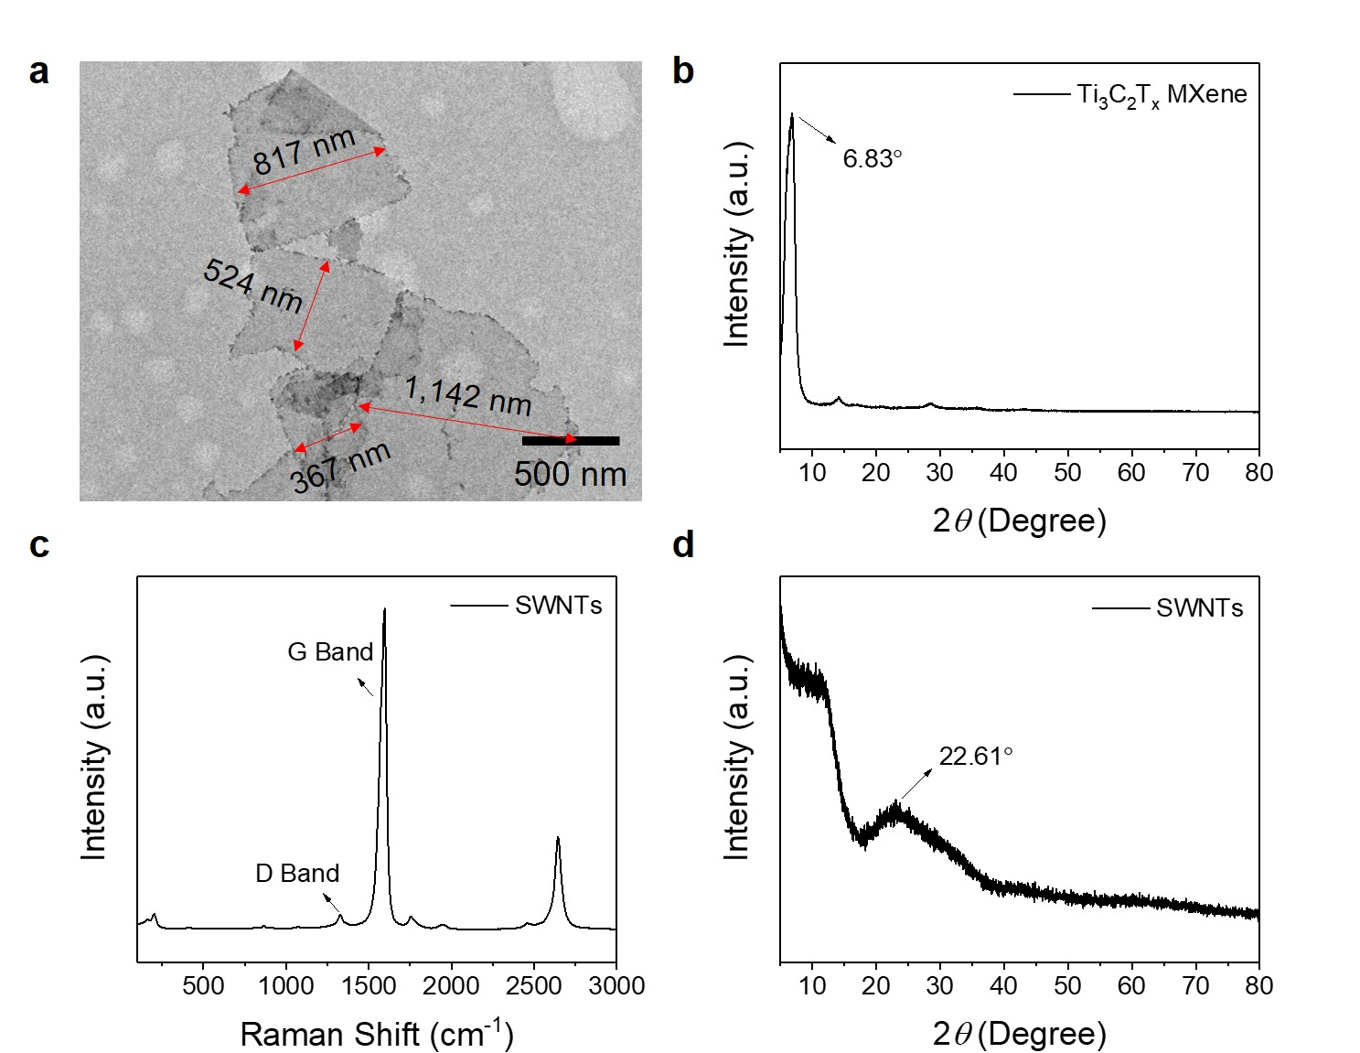

**Fig. S1 Characterizations of Ti3C2Tx MXene nanosheets and SWNTs.** (**a**) Representative TEM image of Ti3C2Tx MXene nanosheets. The average diameter of as-exfoliated MXene nanosheets was measured to be ca. 710 nm. (**b**) XRD pattern of Ti3C2Tx MXene multilayers exhibited a representative peak of 6.83°. According to Bragg’s Law, the interlayer spacing of MXene layer was calculated to be 12.9 Å. (**c**) Raman spectrum of SWNTs showed two representative D and G peaks at 1,324 and 1,596 cm–1, respectively. D band represented the presence of defects in SWNTs. The *ID*/*IG* ratio was 0.047, indicating low level of defects in SWNTs. (**d**) XRD pattern of SWNTs exhibited a representative peak of 22.61°.

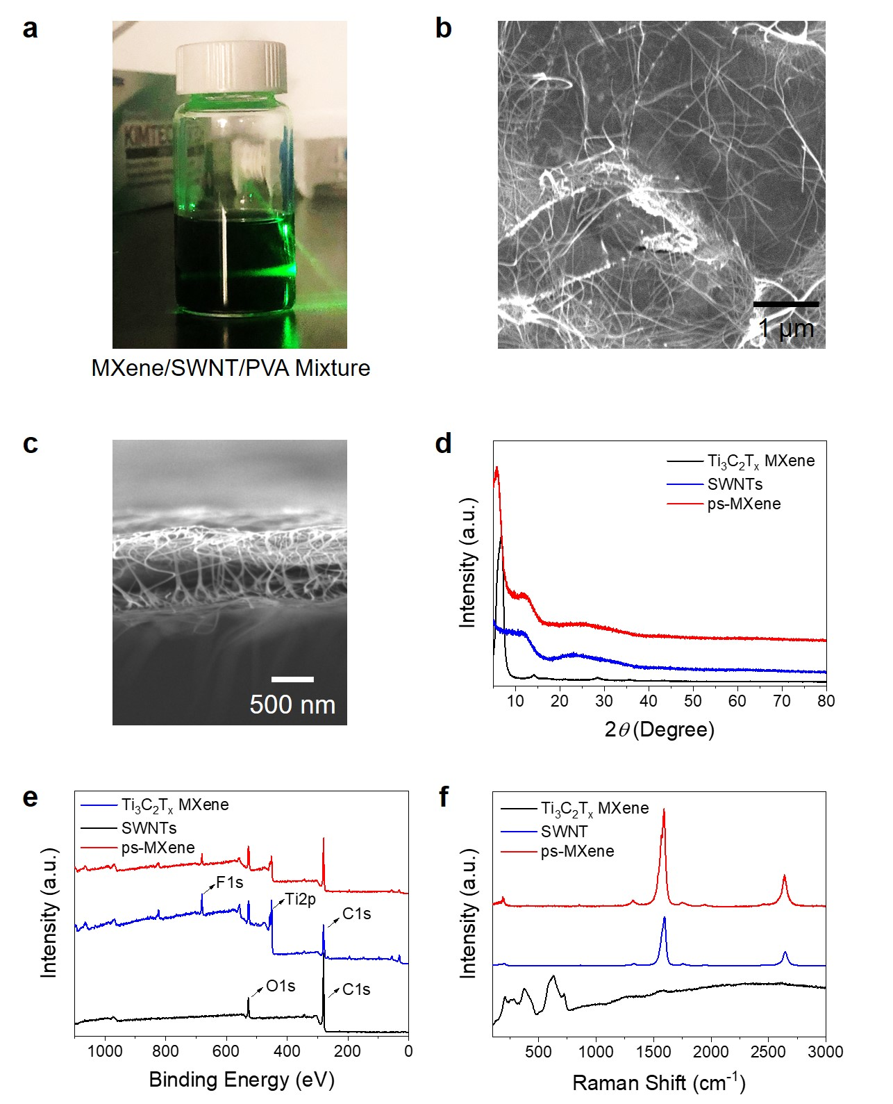

**Fig. S2 Characterizations of ps-MXene layers.** (**a**) Tyndall effect of the mixture of MXene/SWNT/PVA at the mass ratio of 60/30/10. No aggregation was observed. (**b**) Top-down SEM image of ps-MXene layer. Interconnected SWNTs were observed on the surface of ps-MXene layer. (**c**) Cross-sectional SEM image of ps-MXene layer. SWNTs were well dispersed within the ps-MXene layer. (**d**) XRD patterns of Ti3C2Tx MXene, SWNTs, and ps-MXene layers. The XRD pattern of ps-MXene layer exhibited the (002) diﬀraction peak at 5.79° and the representative peaks of SWNTs at 24.4°, indicating the prospective assembly of MXene nanosheets and SWNTs. (**e**) XPS spectra of MXene nanosheets, SWNTs, and ps-MXene layer (at the MXene/SWNT/PVA ratio of 45/45/10). The characteristic peaks of F1s, Ti2p, C1s, and O1s were observed in the XPS spectrum of ps-MXene layer. (**f**) Raman spectra of MXene nanosheets, SWNTs, and ps-MXene layer (at the MXene/SWNT/PVA ratio of 45/45/10).

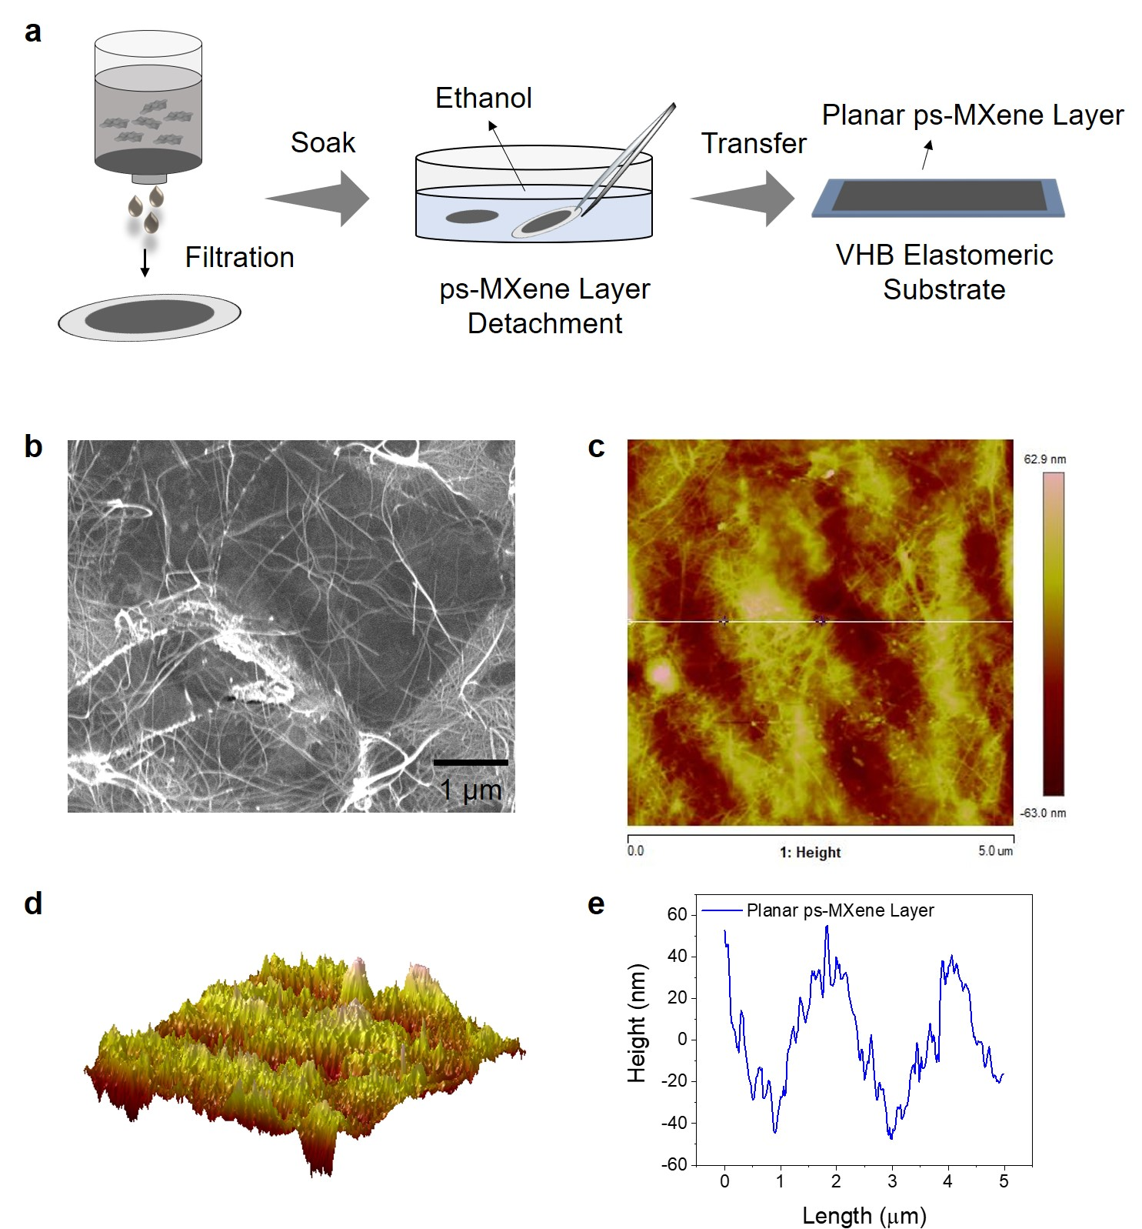

**Fig. S3 Fabrication of *G0* sensor and characterizations of planar ps-MXene layer.** (**a**) Schematic illustration of *G0*sensor fabrication. (**b**) Top-down SEM image ofplanar ps-MXene layer. (**c**) AFM image of planar ps-MXene layer. (**d**) 3D AFM image of planar ps-MXene layer. (**e**) Depth profile of planar ps-MXene layer along the white line in (**c**).

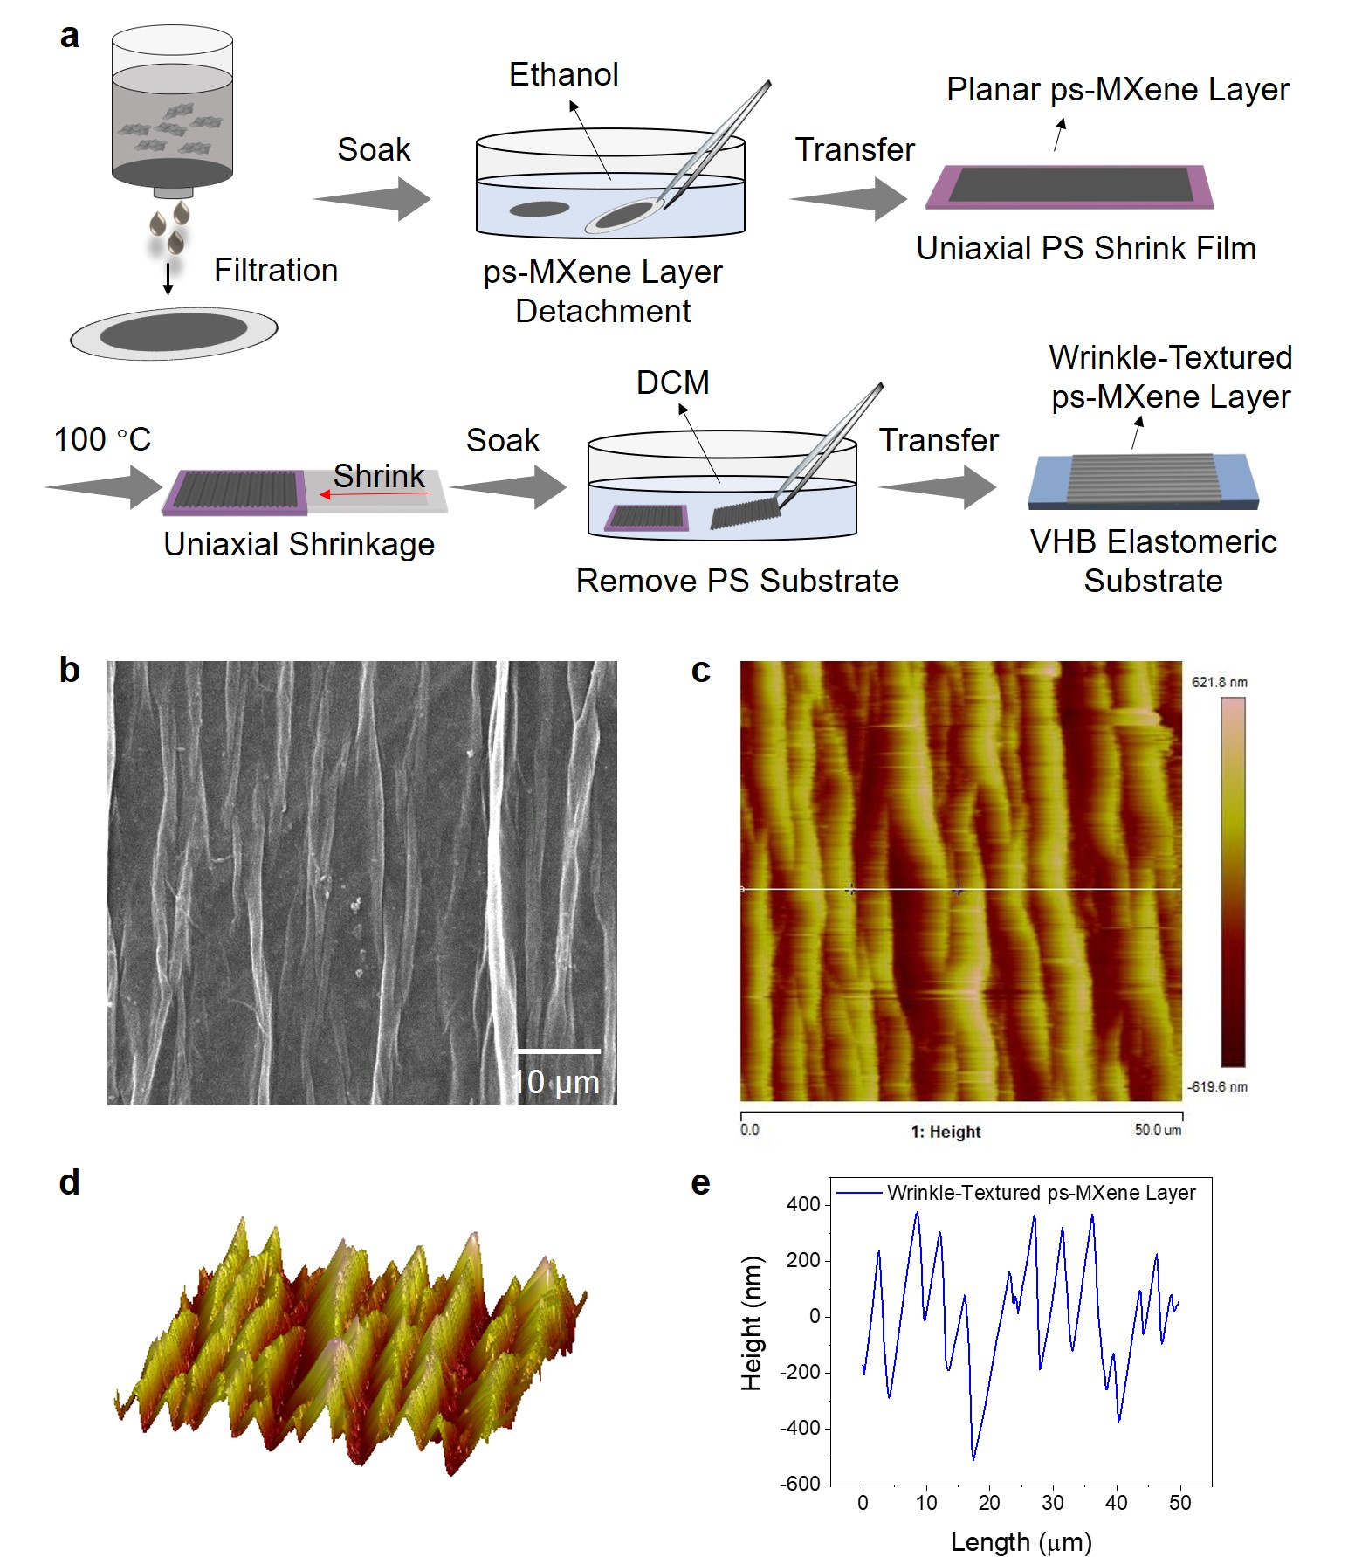

**Fig. S4 Fabrication of *G1*-1D sensor and characterizations of wrinkle-textured ps-MXene layer.** (**a**) Schematic illustration of *G1*-1D sensor fabrication. (**b**) Top-down SEM image ofwrinkle-textured ps-MXene layer. (**c**) AFM image ofwrinkle-textured ps-MXene layer. (d) 3D AFM image ofwrinkle-textured ps-MXene layer. (**e**) Depth profile of wrinkle-textured ps-MXene layer along the white line in (**c**).

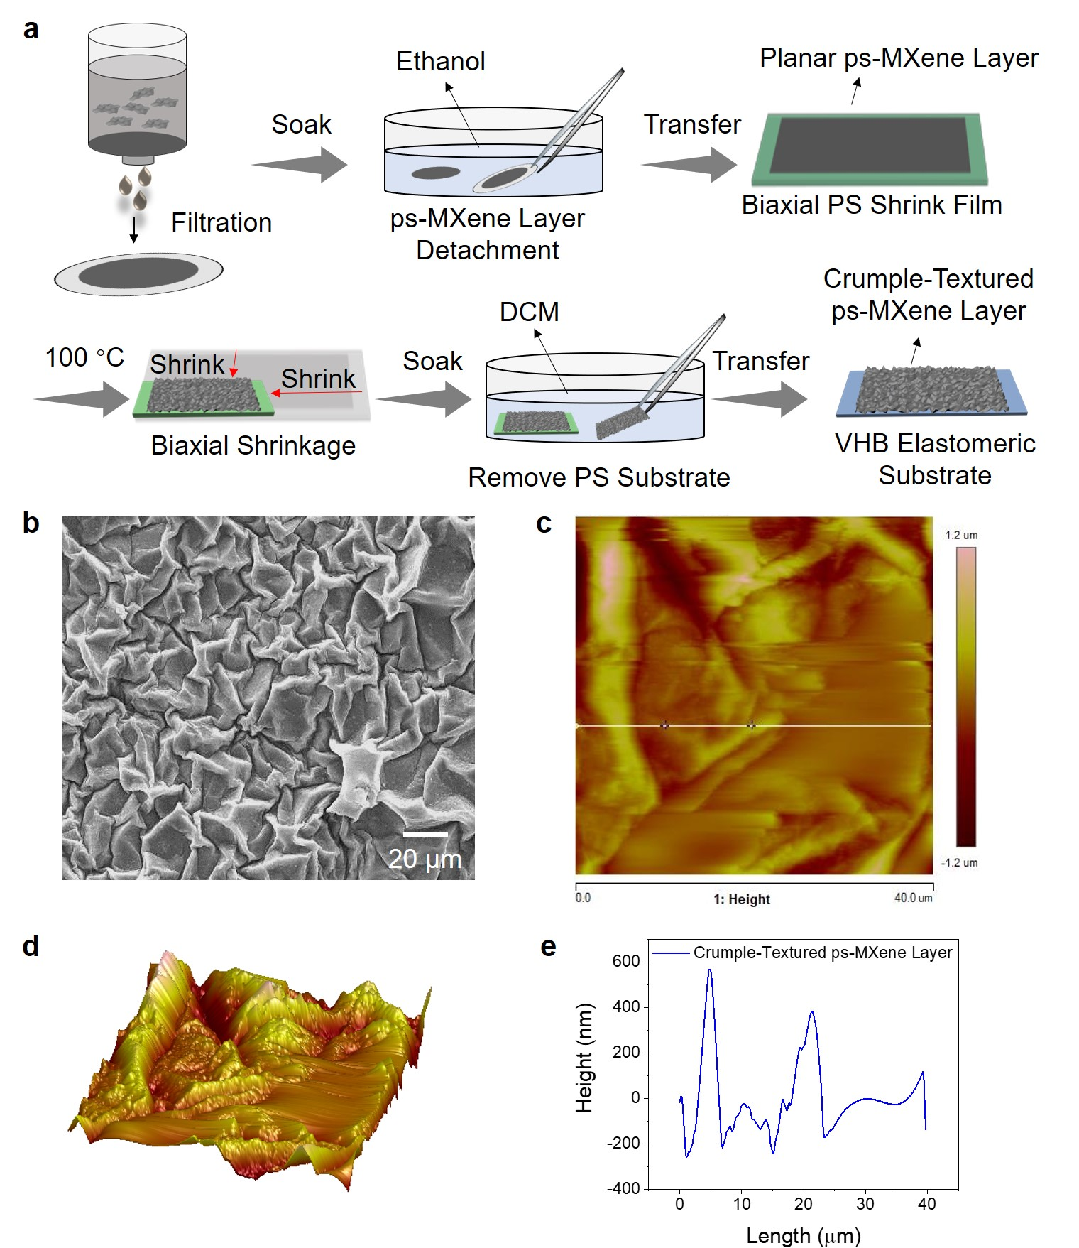

**Fig. S5 Fabrication of *G1*-2D sensor and characterizations of crumple-textured ps-MXene layer.** (**a**) Schematic illustration of *G1*-2D sensor fabrication. (**b**) Top-down SEM image ofcrumple-textured ps-MXene layer. (**c**) AFM image ofcrumple-textured ps-MXene layer. (d) 3D AFM image ofcrumple-textured ps-MXene layer. (**e**) Depth profile of crumple-textured ps-MXene layer along the white line in (**c**).

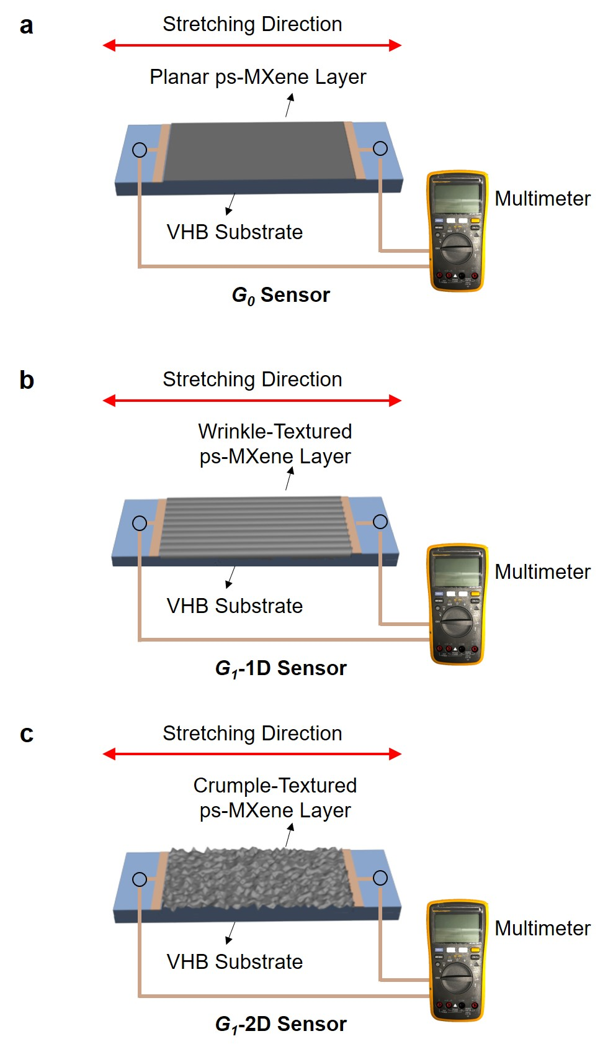

**Fig. S6** **Measurement of strain sensing performance of *G0*, *G1*-1D, and *G*1-2D sensors.** By applying uniaxial strains on **(a)** *G0*, **(b)** *G1*-1D, and **(c)** *G1*-2D sensors at designated directions, their resistance–strain profiles were monitored and recorded by multimeters.

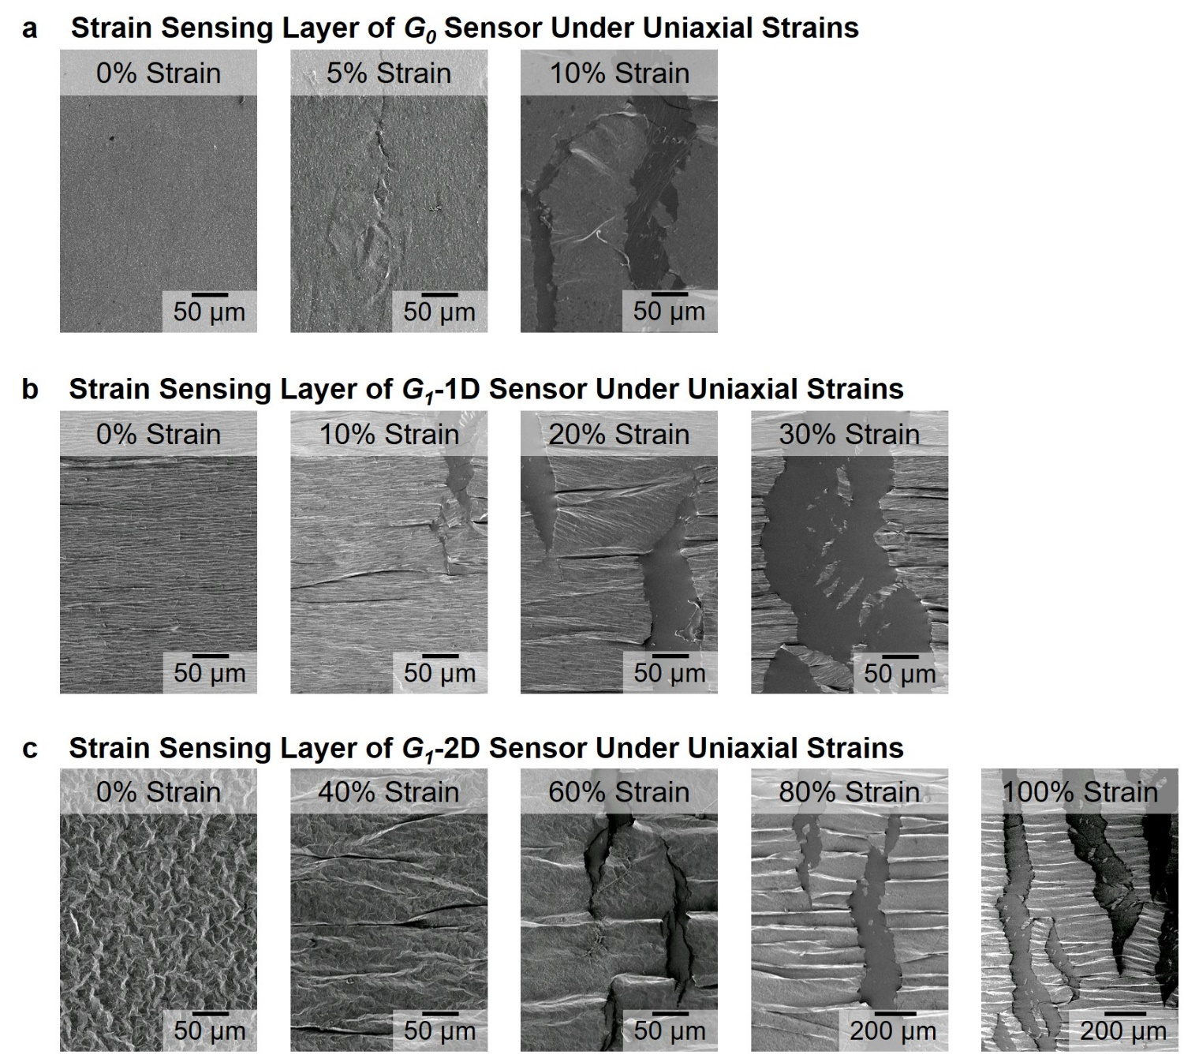

**Fig. S7 SEM images of *G0*, *G1*-1D, and *G1*-2D sensors under various uniaxial strains.** The dimensions of the sensing layers of *G0*, *G1*-1D, and *G1*-2D sensorswere kept at the same: a rectangular shape with a length of 2 cm and a width of 1 cm.The *G0*, *G1*-1D, and *G1*-2D sensors demonstrated different propagation behaviors of surface cracks under uniaxial strains.

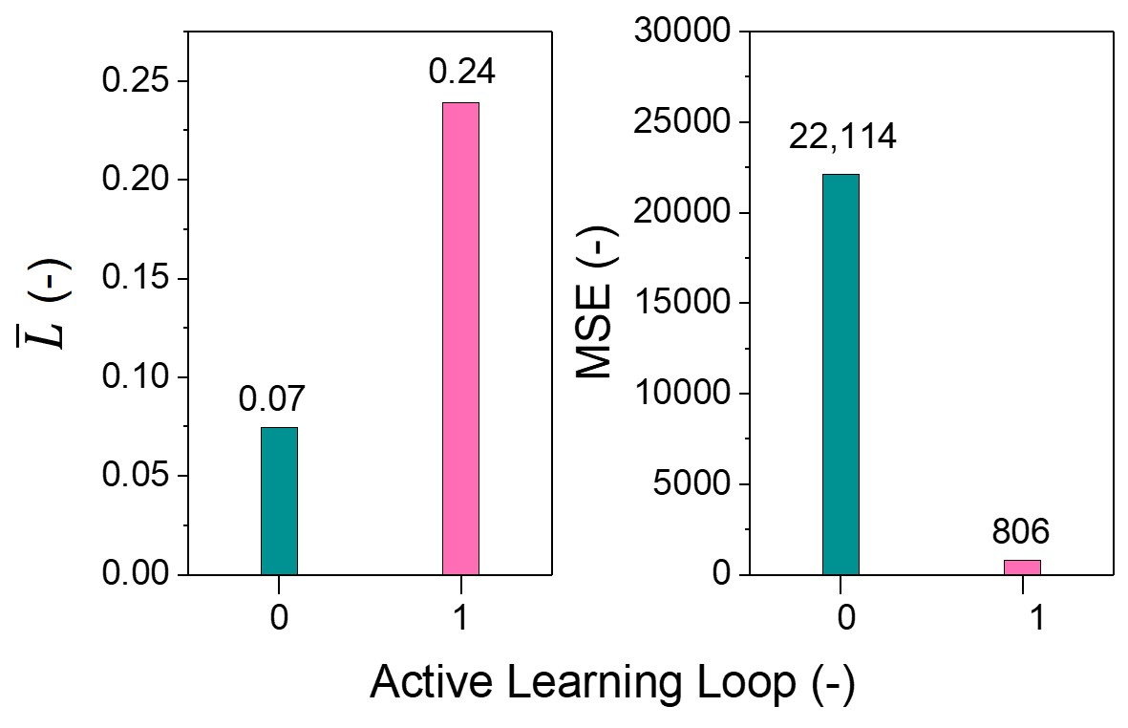

**Fig. S8 Evolution of a preliminary navigation model after first loop of active learning.** 11 fabrication recipes were randomly selected to produce 5 *G0*, 3 *G1*-1D, and 3 *G1*-2D sensors, and 11 data points were collected to construct a preliminary navigation model. The decision programs suggested 5 targeted data points with the largest *A Scores* for next loop of active learning. 4 representative strain labels (*ε0*, *ε10*, *ε100*, *εmax*) were recognized in the resistance–strain profiles of model-suggested *Gn* sensors, and new data points (composed of recipe and strain labels) were input into the decision programs for the next loop of active learning. After one loop of active learning, the of navigation model increased from 0.07 to 0.24, showing that the boundaries of navigation model expanded within the sensor design space. On the other hand, the MSE of navigation model largely reduced from 22,114 to 806, indicating that the navigation model exhibited higher prediction accuracy and possessed better understanding regarding the correlations between fabrication recipes and sensing characteristics.

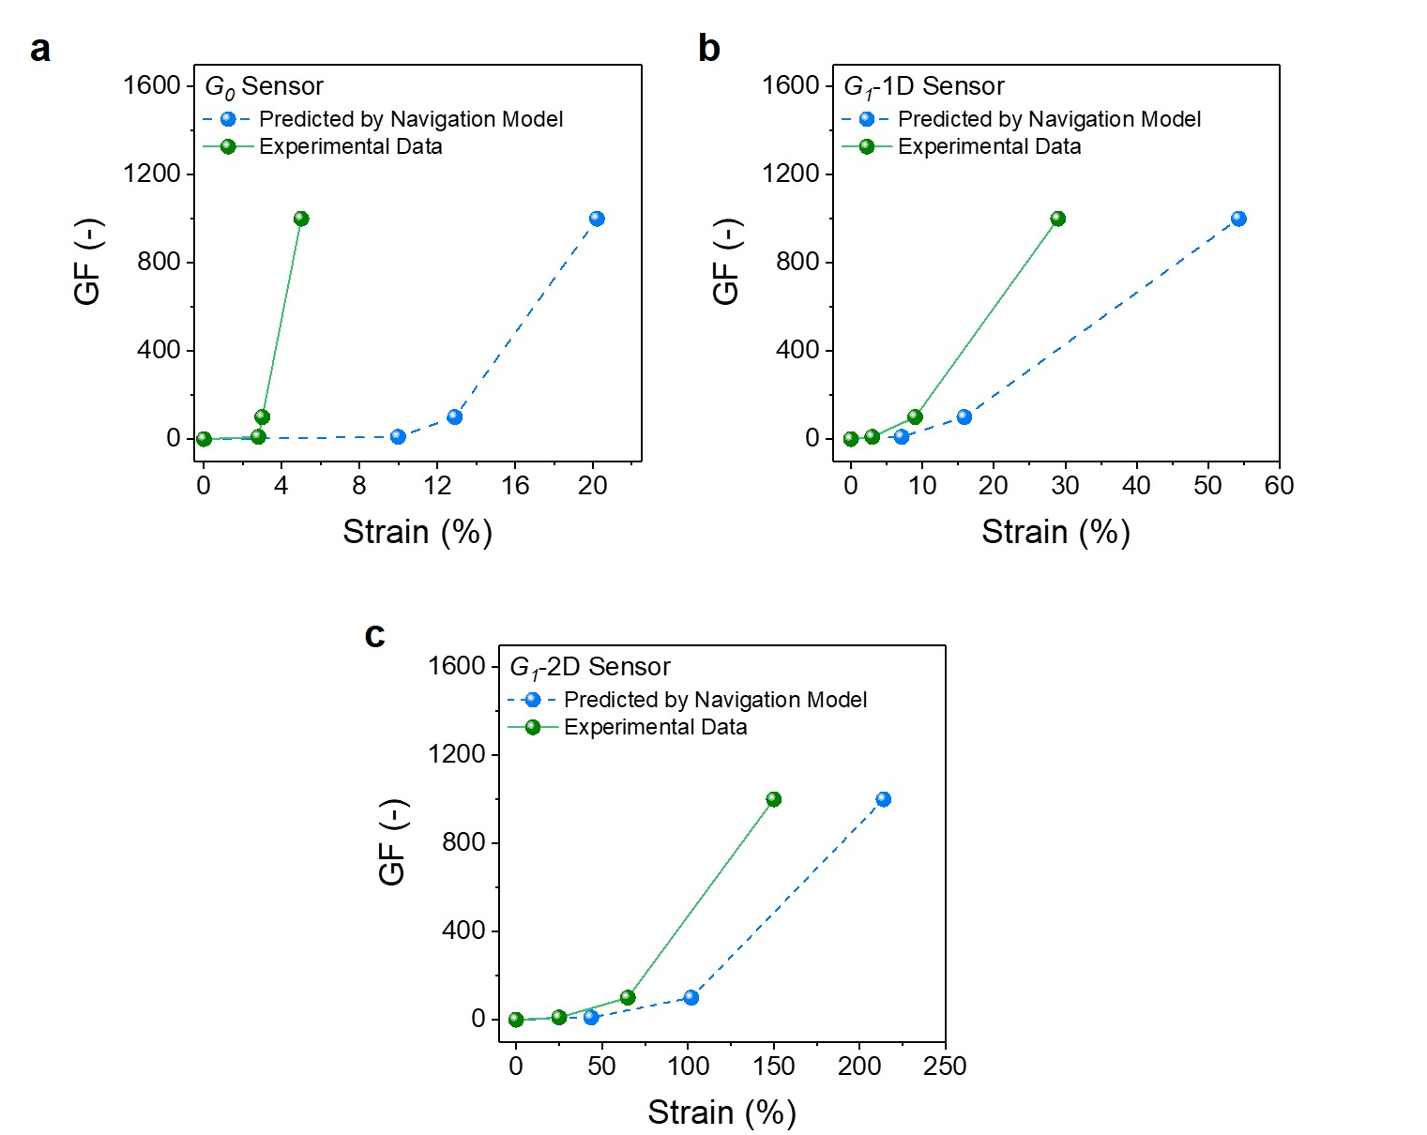

**Fig. S9 Prediction performance of a trained navigation model on *G*0, *G*1-1D, and *G*1-2D sensors.** (**a**) Prediction performance of a trained navigation model on a *G*0 sensor (MXene/SWNT/PVA ratio of 69/13/18; sensing layer thickness of 954 nm). (**b**) Prediction performance of a trained navigation model on a *G*1-1D sensor (MXene/SWNT/PVA ratio of 12/84/4; sensing layer thickness of 465 nm). (**c**) Prediction performance of a trained navigation model on a *G*1-2D sensor (MXene/SWNT/PVA ratio of 100/0/0; sensing layer thickness of 200 nm).

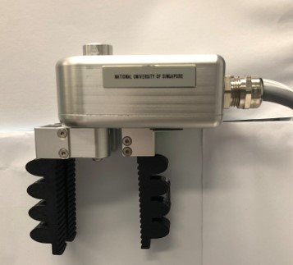

**Fig. S10 Configuration of a soft pneumatic gripper.** A soft gripper was constructed by multiple bellows-type soft actuators. Each bellows-type soft actuator consisted of one air channel, which was inflated upon pressurization for bending. Upon positive gas pressure, the soft gripper was pneumatically inflated and bent along the long axis of its soft robotic body. Three soft actuators acted similar as human fingers to grasp objects, and higher positive gas pressure led to larger degrees of bending.

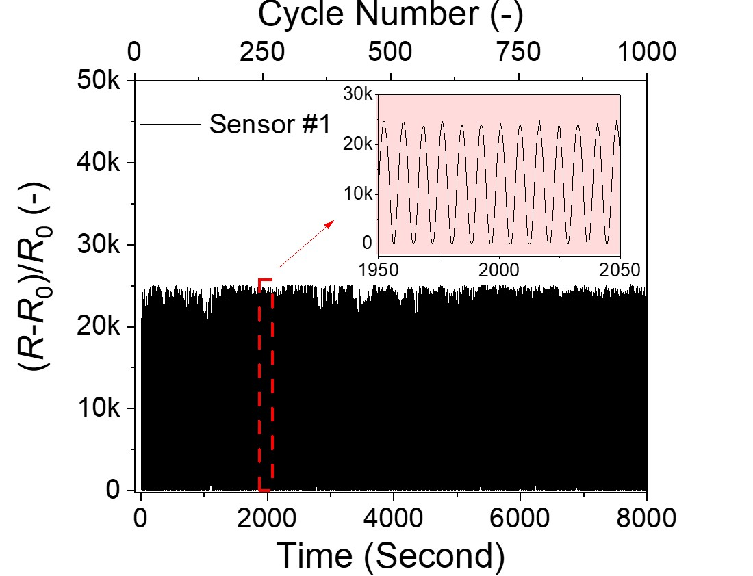

**Fig. S11 Stability test of Sensor #1 under repeated uniaxial strains to 26%.**

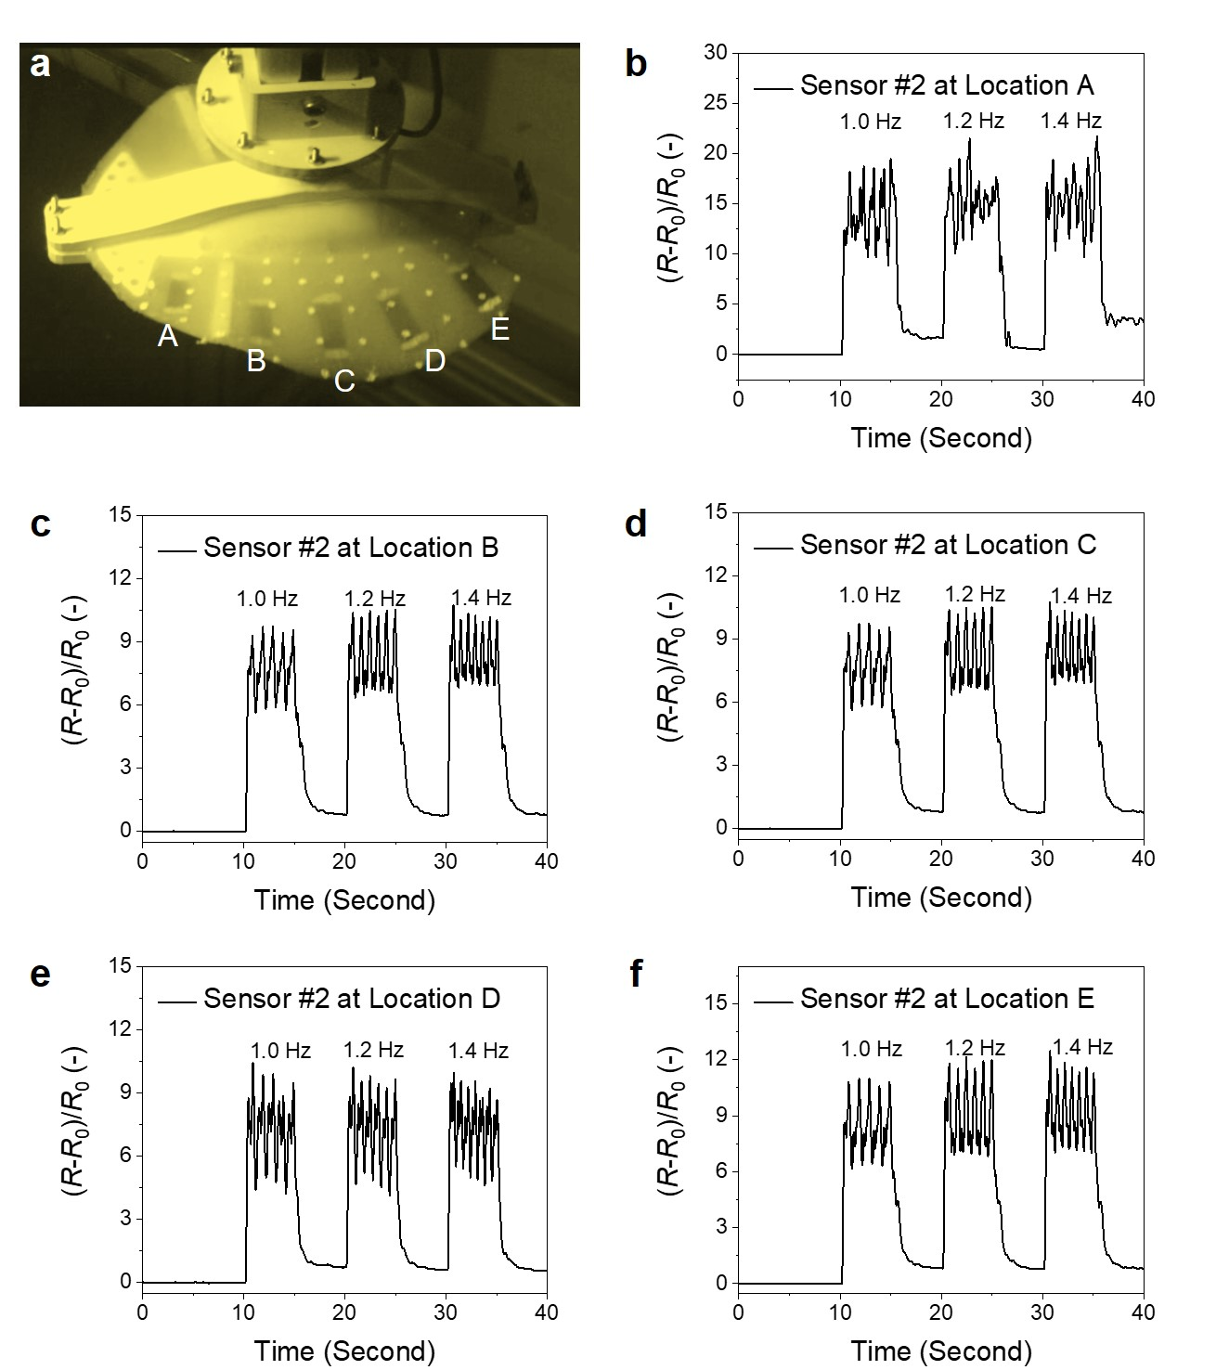

**Fig. S12 Resistance**–**strain profiles of five *G0* sensors (i.e., Sensor #2) embedded within multiple locations of** **a soft swimmer robot.** (**a**) Photograph of a soft swimmer robot embedded with five model-suggested*G0* sensors (i.e., Sensor #2) at different locations. (**b**–**f**) Strain sensing performance of model-suggested *G0* sensors (i.e., Sensor #2) embedded within multiple locations of a soft swimmer robot. The flapping frequencies in all figures were kept the same. For each figure, the flapping frequency gradually increased from 1.0 to 1.2 and 1.4 Hz.

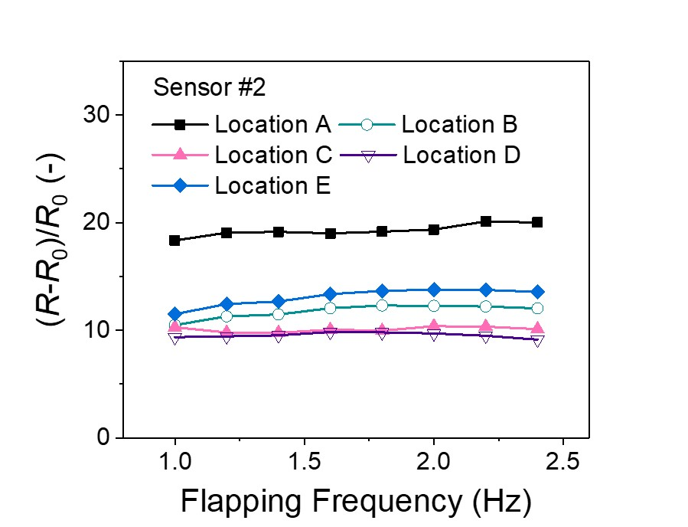

**Fig. S13 Sensing stability of model-suggested *G0* sensor (i.e.,** **Sensor #2)** **embedded within** **multiple locations of a soft swimmer robot under different flapping frequencies.**

**Table S1 Feasibility grades of delaminating ps-MXene layers from PVDF membranes.** “Feasible” cases refer to the conditions that the filteredps-MXene layers were completely detached from PVDF membranes. “Fragile” cases refer to the conditions that the filtered ps-MXene layers exhibited visible fractures after the detachment. “Fail” cases refer to the conditions that the filtered ps-MXene layers were stuck on PVDF membranes. A total of 351 delamination tests were conducted.

|  |  |  |  |  |  |  |  |  |  |  |
| --- | --- | --- | --- | --- | --- | --- | --- | --- | --- | --- |
| Feasibility Grades of ps-MXene Layer Delamination | | | | | | | | | | |
| Index | **MXene Loading**  **(wt.%)** | **SWNT Loading**  **(wt.%)** | **PVA Loading**  **(wt.%)** | **Case**  **(–)** |  | **Index** | **MXene**  **Loading**  **(wt.%)** | **SWNT**  **Loading**  **(wt.%)** | **PVA**  **Loading**  **(wt.%)** | **Case**  **(–)** |
| 1 | 100 | 0 | 0 | Feasible |  | **177** | 12 | 28 | 60 | Fail |
| 2 | 96 | 0 | 4 | Feasible |  | **178** | 8 | 28 | 64 | Fail |
| 3 | 92 | 0 | 8 | Feasible |  | **179** | 4 | 28 | 68 | Fail |
| 4 | 88 | 0 | 12 | Feasible |  | **180** | 0 | 28 | 72 | Fail |
| 5 | 84 | 0 | 16 | Feasible |  | **181** | 68 | 32 | 0 | Feasible |
| 6 | 80 | 0 | 20 | Fragile |  | **182** | 64 | 32 | 4 | Feasible |
| 7 | 76 | 0 | 24 | Fragile |  | **183** | 60 | 32 | 8 | Feasible |
| 8 | 72 | 0 | 28 | Fragile |  | **184** | 56 | 32 | 12 | Feasible |
| 9 | 68 | 0 | 32 | Fragile |  | **185** | 52 | 32 | 16 | Feasible |
| 10 | 64 | 0 | 36 | Fail |  | **186** | 48 | 32 | 20 | Feasible |
| 11 | 60 | 0 | 40 | Fail |  | **187** | 44 | 32 | 24 | Fragile |
| 12 | 56 | 0 | 44 | Fail |  | **188** | 40 | 32 | 28 | Fail |
| 13 | 52 | 0 | 48 | Fail |  | **189** | 36 | 32 | 32 | Fail |
| 14 | 48 | 0 | 52 | Fail |  | **190** | 32 | 32 | 36 | Fail |
| 15 | 44 | 0 | 56 | Fail |  | **191** | 28 | 32 | 40 | Fail |
| 16 | 40 | 0 | 60 | Fail |  | **192** | 24 | 32 | 44 | Fail |
| 17 | 36 | 0 | 64 | Fail |  | **193** | 20 | 32 | 48 | Fail |
| 18 | 32 | 0 | 68 | Fail |  | **194** | 16 | 32 | 52 | Fail |
| 19 | 28 | 0 | 72 | Fail |  | **195** | 12 | 32 | 56 | Fail |
| 20 | 24 | 0 | 76 | Fail |  | **196** | 8 | 32 | 60 | Fail |
| 21 | 20 | 0 | 80 | Fail |  | **197** | 4 | 32 | 64 | Fail |
| 22 | 16 | 0 | 84 | Fail |  | **198** | 0 | 32 | 68 | Fail |
| 23 | 12 | 0 | 88 | Fail |  | **199** | 64 | 36 | 0 | Feasible |
| 24 | 8 | 0 | 92 | Fail |  | **200** | 60 | 36 | 4 | Feasible |
| 25 | 4 | 0 | 96 | Fail |  | **201** | 56 | 36 | 8 | Feasible |
| 26 | 0 | 0 | 100 | Fail |  | **202** | 52 | 36 | 12 | Feasible |
| 27 | 96 | 4 | 0 | Feasible |  | **203** | 48 | 36 | 16 | Feasible |
| 28 | 92 | 4 | 4 | Feasible |  | **204** | 44 | 36 | 20 | Feasible |
| 29 | 88 | 4 | 8 | Feasible |  | **205** | 40 | 36 | 24 | Feasible |
| 30 | 84 | 4 | 12 | Feasible |  | **206** | 36 | 36 | 28 | Fail |
| 31 | 80 | 4 | 16 | Feasible |  | **207** | 32 | 36 | 32 | Fragile |
| 32 | 76 | 4 | 20 | Fragile |  | **208** | 28 | 36 | 36 | Fail |
| 33 | 72 | 4 | 24 | Fragile |  | **209** | 24 | 36 | 40 | Fail |
| 34 | 68 | 4 | 28 | Fragile |  | **210** | 20 | 36 | 44 | Fail |
| 35 | 64 | 4 | 32 | Fail |  | **211** | 16 | 36 | 48 | Fail |
| 36 | 60 | 4 | 36 | Fail |  | **212** | 12 | 36 | 52 | Fail |
| 37 | 56 | 4 | 40 | Fail |  | **213** | 8 | 36 | 56 | Fail |
| 38 | 52 | 4 | 44 | Fail |  | **214** | 4 | 36 | 60 | Fail |
| 39 | 48 | 4 | 48 | Fail |  | **215** | 0 | 36 | 64 | Fail |
| 40 | 44 | 4 | 52 | Fail |  | **216** | 60 | 40 | 0 | Feasible |
| 41 | 40 | 4 | 56 | Fail |  | **217** | 56 | 40 | 4 | Feasible |
| 42 | 36 | 4 | 60 | Fail |  | **218** | 52 | 40 | 8 | Feasible |
| 43 | 32 | 4 | 64 | Fail |  | **219** | 48 | 40 | 12 | Feasible |
| 44 | 28 | 4 | 68 | Fail |  | **220** | 44 | 40 | 16 | Feasible |
| 45 | 24 | 4 | 72 | Fail |  | **221** | 40 | 40 | 20 | Feasible |
| 46 | 20 | 4 | 76 | Fail |  | **222** | 36 | 40 | 24 | Feasible |
| 47 | 16 | 4 | 80 | Fail |  | **223** | 32 | 40 | 28 | Fragile |
| 48 | 12 | 4 | 84 | Fail |  | **224** | 28 | 40 | 32 | Fragile |
| 49 | 8 | 4 | 88 | Fail |  | **225** | 24 | 40 | 36 | Fragile |
| 50 | 4 | 4 | 92 | Fail |  | **226** | 20 | 40 | 40 | Fragile |
| 51 | 0 | 4 | 96 | Fail |  | **227** | 16 | 40 | 44 | Fail |
| 52 | 92 | 8 | 0 | Feasible |  | **228** | 12 | 40 | 48 | Fail |
| 53 | 88 | 8 | 4 | Feasible |  | **229** | 8 | 40 | 52 | Fail |
| 54 | 84 | 8 | 8 | Feasible |  | **230** | 4 | 40 | 56 | Fail |
| 55 | 80 | 8 | 12 | Feasible |  | **231** | 0 | 40 | 60 | Fail |
| 56 | 76 | 8 | 16 | Feasible |  | **232** | 56 | 44 | 0 | Feasible |
| 57 | 72 | 8 | 20 | Fragile |  | **233** | 52 | 44 | 4 | Feasible |
| 58 | 68 | 8 | 24 | Fail |  | **234** | 48 | 44 | 8 | Feasible |
| 59 | 64 | 8 | 28 | Fail |  | **235** | 44 | 44 | 12 | Feasible |
| 60 | 60 | 8 | 32 | Fail |  | **236** | 40 | 44 | 16 | Feasible |
| 61 | 56 | 8 | 36 | Fail |  | **237** | 36 | 44 | 20 | Feasible |
| 62 | 52 | 8 | 40 | Fail |  | **238** | 32 | 44 | 24 | Feasible |
| 63 | 48 | 8 | 44 | Fail |  | **239** | 28 | 44 | 28 | Feasible |
| 64 | 44 | 8 | 48 | Fail |  | **240** | 24 | 44 | 32 | Feasible |
| 65 | 40 | 8 | 52 | Fail |  | **241** | 20 | 44 | 36 | Fragile |
| 66 | 36 | 8 | 56 | Fail |  | **242** | 16 | 44 | 40 | Fragile |
| 67 | 32 | 8 | 60 | Fail |  | **243** | 12 | 44 | 44 | Fail |
| 68 | 28 | 8 | 64 | Fail |  | **244** | 8 | 44 | 48 | Fail |
| 69 | 24 | 8 | 68 | Fail |  | **245** | 4 | 44 | 52 | Fail |
| 70 | 20 | 8 | 72 | Fail |  | **246** | 0 | 44 | 56 | Fail |
| 71 | 16 | 8 | 76 | Fail |  | **247** | 52 | 48 | 0 | Feasible |
| 72 | 12 | 8 | 80 | Fail |  | **248** | 48 | 48 | 4 | Feasible |
| 73 | 8 | 8 | 84 | Fail |  | **249** | 44 | 48 | 8 | Feasible |
| 74 | 4 | 8 | 88 | Fail |  | **250** | 40 | 48 | 12 | Feasible |
| 75 | 0 | 8 | 92 | Fail |  | **251** | 36 | 48 | 16 | Feasible |
| 76 | 88 | 12 | 0 | Feasible |  | **252** | 32 | 48 | 20 | Feasible |
| 77 | 84 | 12 | 4 | Feasible |  | **253** | 28 | 48 | 24 | Feasible |
| 78 | 80 | 12 | 8 | Feasible |  | **254** | 24 | 48 | 28 | Feasible |
| 79 | 76 | 12 | 12 | Feasible |  | **255** | 20 | 48 | 32 | Feasible |
| 80 | 72 | 12 | 16 | Feasible |  | **256** | 16 | 48 | 36 | Feasible |
| 81 | 68 | 12 | 20 | Fragile |  | **257** | 12 | 48 | 40 | Fragile |
| 82 | 64 | 12 | 24 | Fail |  | **258** | 8 | 48 | 44 | Fail |
| 83 | 60 | 12 | 28 | Fail |  | **259** | 4 | 48 | 48 | Fail |
| 84 | 56 | 12 | 32 | Fail |  | **260** | 0 | 48 | 52 | Fail |
| 85 | 52 | 12 | 36 | Fail |  | **261** | 48 | 52 | 0 | Feasible |
| 86 | 48 | 12 | 40 | Fail |  | **262** | 44 | 52 | 4 | Feasible |
| 87 | 44 | 12 | 44 | Fail |  | **263** | 40 | 52 | 8 | Feasible |
| 88 | 40 | 12 | 48 | Fail |  | **264** | 36 | 52 | 12 | Feasible |
| 89 | 36 | 12 | 52 | Fail |  | **265** | 32 | 52 | 16 | Feasible |
| 90 | 32 | 12 | 56 | Fail |  | **266** | 28 | 52 | 20 | Feasible |
| 91 | 28 | 12 | 60 | Fail |  | **267** | 24 | 52 | 24 | Feasible |
| 92 | 24 | 12 | 64 | Fail |  | **268** | 20 | 52 | 28 | Feasible |
| 93 | 20 | 12 | 68 | Fail |  | **269** | 16 | 52 | 32 | Feasible |
| 94 | 16 | 12 | 72 | Fail |  | **270** | 12 | 52 | 36 | Feasible |
| 95 | 12 | 12 | 76 | Fail |  | **271** | 8 | 52 | 40 | Fragile |
| 96 | 8 | 12 | 80 | Fail |  | **272** | 4 | 52 | 44 | Fail |
| 97 | 4 | 12 | 84 | Fail |  | **273** | 0 | 52 | 48 | Fail |
| 98 | 0 | 12 | 88 | Fail |  | **274** | 44 | 56 | 0 | Feasible |
| 99 | 84 | 16 | 0 | Feasible |  | **275** | 40 | 56 | 4 | Feasible |
| 100 | 80 | 16 | 4 | Feasible |  | **276** | 36 | 56 | 8 | Feasible |
| 101 | 76 | 16 | 8 | Feasible |  | **277** | 32 | 56 | 12 | Feasible |
| 102 | 72 | 16 | 12 | Feasible |  | **278** | 28 | 56 | 16 | Feasible |
| 103 | 68 | 16 | 16 | Feasible |  | **279** | 24 | 56 | 20 | Feasible |
| 104 | 64 | 16 | 20 | Fragile |  | **280** | 20 | 56 | 24 | Feasible |
| 105 | 60 | 16 | 24 | Fragile |  | **281** | 16 | 56 | 28 | Feasible |
| 106 | 56 | 16 | 28 | Fail |  | **282** | 12 | 56 | 32 | Feasible |
| 107 | 52 | 16 | 32 | Fail |  | **283** | 8 | 56 | 36 | Feasible |
| 108 | 48 | 16 | 36 | Fail |  | **284** | 4 | 56 | 40 | Feasible |
| 109 | 44 | 16 | 40 | Fail |  | **285** | 0 | 56 | 44 | Fail |
| 110 | 40 | 16 | 44 | Fail |  | **286** | 40 | 60 | 0 | Feasible |
| 111 | 36 | 16 | 48 | Fail |  | **287** | 36 | 60 | 4 | Feasible |
| 112 | 32 | 16 | 52 | Fail |  | **288** | 32 | 60 | 8 | Feasible |
| 113 | 28 | 16 | 56 | Fail |  | **289** | 28 | 60 | 12 | Feasible |
| 114 | 24 | 16 | 60 | Fail |  | **290** | 24 | 60 | 16 | Feasible |
| 115 | 20 | 16 | 64 | Fail |  | **291** | 20 | 60 | 20 | Feasible |
| 116 | 16 | 16 | 68 | Fail |  | **292** | 16 | 60 | 24 | Feasible |
| 117 | 12 | 16 | 72 | Fail |  | **293** | 12 | 60 | 28 | Feasible |
| 118 | 8 | 16 | 76 | Fail |  | **294** | 8 | 60 | 32 | Feasible |
| 119 | 4 | 16 | 80 | Fail |  | **295** | 4 | 60 | 36 | Feasible |
| 120 | 0 | 16 | 84 | Fail |  | **296** | 0 | 60 | 40 | Feasible |
| 121 | 80 | 20 | 0 | Feasible |  | **297** | 36 | 64 | 0 | Feasible |
| 122 | 76 | 20 | 4 | Feasible |  | **298** | 32 | 64 | 4 | Feasible |
| 123 | 72 | 20 | 8 | Feasible |  | **299** | 28 | 64 | 8 | Feasible |
| 124 | 68 | 20 | 12 | Feasible |  | **300** | 24 | 64 | 12 | Feasible |
| 125 | 64 | 20 | 16 | Feasible |  | **301** | 20 | 64 | 16 | Feasible |
| 126 | 60 | 20 | 20 | Feasible |  | **302** | 16 | 64 | 20 | Feasible |
| 127 | 56 | 20 | 24 | Fail |  | **303** | 12 | 64 | 24 | Feasible |
| 128 | 52 | 20 | 28 | Fail |  | **304** | 8 | 64 | 28 | Feasible |
| 129 | 48 | 20 | 32 | Fail |  | **305** | 4 | 64 | 32 | Feasible |
| 130 | 44 | 20 | 36 | Fail |  | **306** | 0 | 64 | 36 | Feasible |
| 131 | 40 | 20 | 40 | Fail |  | **307** | 32 | 68 | 0 | Feasible |
| 132 | 36 | 20 | 44 | Fail |  | **308** | 28 | 68 | 4 | Feasible |
| 133 | 32 | 20 | 48 | Fail |  | **309** | 24 | 68 | 8 | Feasible |
| 134 | 28 | 20 | 52 | Fail |  | **310** | 20 | 68 | 12 | Feasible |
| 135 | 24 | 20 | 56 | Fail |  | **311** | 16 | 68 | 16 | Feasible |
| 136 | 20 | 20 | 60 | Fail |  | **312** | 12 | 68 | 20 | Feasible |
| 137 | 16 | 20 | 64 | Fail |  | **313** | 8 | 68 | 24 | Feasible |
| 138 | 12 | 20 | 68 | Fail |  | **314** | 4 | 68 | 28 | Feasible |
| 139 | 8 | 20 | 72 | Fail |  | **315** | 0 | 68 | 32 | Feasible |
| 140 | 4 | 20 | 76 | Fail |  | **316** | 28 | 72 | 0 | Feasible |
| 141 | 0 | 20 | 80 | Fail |  | **317** | 24 | 72 | 4 | Feasible |
| 142 | 76 | 24 | 0 | Feasible |  | **318** | 20 | 72 | 8 | Feasible |
| 143 | 72 | 24 | 4 | Feasible |  | **319** | 16 | 72 | 12 | Feasible |
| 144 | 68 | 24 | 8 | Feasible |  | **320** | 12 | 72 | 16 | Feasible |
| 145 | 64 | 24 | 12 | Feasible |  | **321** | 8 | 72 | 20 | Feasible |
| 146 | 60 | 24 | 16 | Feasible |  | **322** | 4 | 72 | 24 | Feasible |
| 147 | 56 | 24 | 20 | Feasible |  | **323** | 0 | 72 | 28 | Feasible |
| 148 | 52 | 24 | 24 | Fail |  | **324** | 24 | 76 | 0 | Feasible |
| 149 | 48 | 24 | 28 | Fail |  | **325** | 20 | 76 | 4 | Feasible |
| 150 | 44 | 24 | 32 | Fail |  | **326** | 16 | 76 | 8 | Feasible |
| 151 | 40 | 24 | 36 | Fail |  | **327** | 12 | 76 | 12 | Feasible |
| 152 | 36 | 24 | 40 | Fail |  | **328** | 8 | 76 | 16 | Feasible |
| 153 | 32 | 24 | 44 | Fail |  | **329** | 4 | 76 | 20 | Feasible |
| 154 | 28 | 24 | 48 | Fail |  | **330** | 0 | 76 | 24 | Feasible |
| 155 | 24 | 24 | 52 | Fail |  | **331** | 20 | 80 | 0 | Feasible |
| 156 | 20 | 24 | 56 | Fail |  | **332** | 16 | 80 | 4 | Feasible |
| 157 | 16 | 24 | 60 | Fail |  | **333** | 12 | 80 | 8 | Feasible |
| 158 | 12 | 24 | 64 | Fail |  | **334** | 8 | 80 | 12 | Feasible |
| 159 | 8 | 24 | 68 | Fail |  | **335** | 4 | 80 | 16 | Feasible |
| 160 | 4 | 24 | 72 | Fail |  | **336** | 0 | 80 | 20 | Feasible |
| 161 | 0 | 24 | 76 | Fail |  | **337** | 16 | 84 | 0 | Feasible |
| 162 | 72 | 28 | 0 | Feasible |  | **338** | 12 | 84 | 4 | Feasible |
| 163 | 68 | 28 | 4 | Feasible |  | **339** | 8 | 84 | 8 | Feasible |
| 164 | 64 | 28 | 8 | Feasible |  | **340** | 4 | 84 | 12 | Feasible |
| 165 | 60 | 28 | 12 | Feasible |  | **341** | 0 | 84 | 16 | Feasible |
| 166 | 56 | 28 | 16 | Feasible |  | **342** | 12 | 88 | 0 | Feasible |
| 167 | 52 | 28 | 20 | Feasible |  | **343** | 8 | 88 | 4 | Feasible |
| 168 | 48 | 28 | 24 | Fail |  | **344** | 4 | 88 | 8 | Feasible |
| 169 | 44 | 28 | 28 | Fail |  | **345** | 0 | 88 | 12 | Feasible |
| 170 | 40 | 28 | 32 | Fail |  | **346** | 8 | 92 | 0 | Feasible |
| 171 | 36 | 28 | 36 | Fail |  | **347** | 4 | 92 | 4 | Feasible |
| 172 | 32 | 28 | 40 | Fail |  | **348** | 0 | 92 | 8 | Feasible |
| 173 | 28 | 28 | 44 | Fail |  | **349** | 4 | 96 | 0 | Feasible |
| 174 | 24 | 28 | 48 | Fail |  | **350** | 0 | 96 | 4 | Fail |
| 175 | 20 | 28 | 52 | Fail |  | **351** | 0 | 100 | 0 | Fail |
| 176 | 16 | 28 | 56 | Fail |  |  |  |  |  |  |

**Table S2 125 data points collected from 12 loops of active learning for navigation model construction.** A total of 12 loops of active learning were executed, and 125 sensors were fabricated cumulatively.

|  |  |  |  |  |  |  |  |  |  |  |  |
| --- | --- | --- | --- | --- | --- | --- | --- | --- | --- | --- | --- |
| **Index** | **Learning**  **Loop** | **Model-Suggested Recipe Labels** | | | | | **Measured Sensor Characteristics** | | | | |
| MXene  Loading  (wt.%) | SWNT  Loading  (wt.%) | PVA  Loading  (wt.%) | Layer  Thickness  (nm) | Layer  Morphology  (**–**) | *ε0*  (%) | *ε10*  (%) | *ε100*  (%) | *εmax*  (%) |
| **1** | 0 | 90 | 5 | 5 | 900 | *G0* | 0.0 | 0.3 | 0.3 | 10.0 |
| **2** | 0 | 90 | 5 | 5 | 300 | *G0* | 0.0 | 2.0 | 3.3 | 30.0 |
| **3** | 0 | 100 | 0 | 0 | 800 | *G1*-2D | 0.0 | 6.7 | 10.0 | 120.0 |
| **4** | 0 | 95 | 5 | 0 | 800 | *G1*-2D | 0.0 | 3.3 | 23.3 | 166.7 |
| **5** | 0 | 100 | 0 | 0 | 800 | *G1*-1D | 0.0 | 1.0 | 3.3 | 36.7 |
| **6** | 0 | 95 | 5 | 0 | 800 | *G1*-1D | 0.0 | 1.0 | 3.3 | 36.7 |
| **7** | 0 | 95 | 0 | 5 | 800 | *G1*-1D | 0.0 | 1.0 | 3.3 | 70.0 |
| **8** | 0 | 100 | 0 | 0 | 800 | *G*0 | 0.0 | 0.3 | 1.0 | 10.0 |
| **9** | 0 | 90 | 5 | 5 | 800 | *G1*-2D | 0.0 | 3.3 | 30.0 | 213.3 |
| **10** | 0 | 90 | 10 | 0 | 800 | *G0* | 0.0 | 3.3 | 3.3 | 13.3 |
| **11** | 0 | 92 | 4 | 4 | 800 | *G0* | 0.0 | 0.2 | 2.0 | 13.3 |
| **12** | 1 | 0 | 60 | 40 | 2,000 | *G0* | 0.0 | 9.1 | 9.5 | 10.0 |
| **13** | 1 | 0 | 60 | 40 | 1,380 | *G0* | 0.0 | 5.3 | 5.9 | 10.5 |
| **14** | 1 | 83 | 17 | 0 | 1,700 | *G0* | 0.0 | 1.1 | 1.8 | 4.2 |
| **15** | 1 | 2 | 58 | 40 | 2,000 | *G1*-1D | 0.0 | 10.6 | 10.6 | 10.6 |
| **16** | 1 | 4 | 56 | 40 | 2,000 | *G1*-2D | 0.0 | 13.3 | 21.7 | 22.8 |
| **17** | 2 | 83 | 0 | 17 | 2,000 | *G0* | 0.0 | 7.0 | 11.3 | 13.4 |
| **18** | 2 | 9 | 52 | 39 | 1,980 | *G0* | 0.0 | 6.8 | 7.4 | 10.5 |
| **19** | 2 | 83 | 0 | 17 | 1,440 | *G0* | 0.0 | 15.2 | 17.1 | 20.0 |
| **20** | 2 | 0 | 96 | 4 | 200 | *G1*-2D | 0.0 | 11.1 | 14.1 | 25.3 |
| **21** | 2 | 83 | 0 | 17 | 1,990 | *G1*-2D | 0.0 | 11.9 | 58.7 | 115.9 |
| **22** | 3 | 3 | 57 | 40 | 220 | *G1*-1D | 0.0 | 7.8 | 9.4 | 20.0 |
| **23** | 3 | 4 | 56 | 40 | 200 | *G0* | 0.0 | 18.0 | 19.8 | 32.0 |
| **24** | 3 | 49 | 30 | 21 | 216 | *G0* | 0.0 | 0.7 | 1.7 | 5.0 |
| **25** | 3 | 16 | 48 | 36 | 200 | *G1*-2D | 0.0 | 11.1 | 18.5 | 20.0 |
| **26** | 3 | 47 | 31 | 22 | 215 | *G1*-1D | 0.0 | 8.2 | 17.3 | 36.4 |
| **27** | 3 | 83 | 0 | 17 | 217 | *G1*-2D | 0.0 | 42.2 | 100.0 | 133.3 |
| **28** | 3 | 83 | 0 | 17 | 213 | *G1*-1D | 0.0 | 14.0 | 24.0 | 60.0 |
| **29** | 3 | 11 | 51 | 38 | 1,171 | *G1*-1D | 0.0 | 16.7 | 20.0 | 33.3 |
| **30** | 4 | 83 | 0 | 17 | 1,839 | *G1*-1D | 0.0 | 1.0 | 20.0 | 33.0 |
| **31** | 4 | 7 | 93 | 0 | 264 | *G1*-1D | 0.0 | 4.0 | 9.0 | 30.0 |
| **32** | 4 | 5 | 95 | 0 | 389 | *G0* | 0.0 | 2.0 | 14.0 | 60.0 |
| **33** | 4 | 25 | 43 | 32 | 907 | *G0* | 0.0 | 5.0 | 6.0 | 12.0 |
| **34** | 4 | 70 | 25 | 5 | 1,744 | *G0* | 0.0 | 0.6 | 4.4 | 6.7 |
| **35** | 4 | 55 | 24 | 21 | 1,405 | *G1*-1D | 0.0 | 18.0 | 20.0 | 28.0 |
| **36** | 4 | 31 | 41 | 28 | 966 | *G1*-2D | 0.0 | 21.0 | 22.0 | 24.0 |
| **37** | 4 | 4 | 94 | 2 | 1,266 | *G1*-1D | 0.0 | 9.5 | 10.0 | 12.2 |
| **38** | 5 | 12 | 88 | 0 | 1,127 | *G1*-2D | 0.0 | 2.5 | 3.0 | 10.0 |
| **39** | 5 | 73 | 27 | 0 | 1,438 | *G1*-2D | 0.0 | 21.4 | 27.1 | 50.0 |
| **40** | 5 | 1 | 95 | 4 | 1,131 | *G0* | 0.0 | 2.1 | 4.7 | 11.6 |
| **41** | 5 | 60 | 38 | 2 | 686 | *G1*-2D | 0.0 | 30.0 | 45.0 | 53.0 |
| **42** | 5 | 36 | 62 | 2 | 205 | *G1*-2D | 0.0 | 21.3 | 33.8 | 81.3 |
| **43** | 5 | 63 | 36 | 1 | 1,651 | *G1*-1D | 0.0 | 2.0 | 4.0 | 26.7 |
| **44** | 5 | 0 | 60 | 40 | 1,642 | *G1*-2D | 0.0 | 15.5 | 16.0 | 18.5 |
| **45** | 5 | 80 | 17 | 3 | 1,875 | *G1*-1D | 0.0 | 2.0 | 32.7 | 35.3 |
| **46** | 6 | 50 | 50 | 0 | 800 | *G0* | 0.0 | 2.0 | 3.3 | 6.7 |
| **47** | 6 | 20 | 80 | 0 | 800 | *G0* | 0.0 | 1.0 | 3.3 | 10.0 |
| **48** | 6 | 72 | 28 | 0 | 800 | *G0* | 0.0 | 1.0 | 3.3 | 6.7 |
| **49** | 6 | 12 | 88 | 0 | 800 | *G0* | 0.0 | 3.3 | 6.7 | 20.0 |
| **50** | 6 | 28 | 72 | 0 | 800 | *G0* | 0.0 | 1.0 | 3.3 | 13.3 |
| **51** | 6 | 96 | 4 | 0 | 800 | *G0* | 0.0 | 1.0 | 3.3 | 16.7 |
| **52** | 6 | 88 | 0 | 12 | 800 | *G0* | 0.0 | 0.1 | 0.5 | 3.3 |
| **53** | 6 | 99 | 0 | 1 | 800 | *G0* | 0.0 | 3.3 | 6.7 | 13.3 |
| **54** | 6 | 45 | 45 | 10 | 800 | *G0* | 0.0 | 3.3 | 6.7 | 36.7 |
| **55** | 6 | 72 | 14 | 14 | 560 | *G0* | 0.0 | 1.0 | 6.7 | 43.3 |
| **56** | 6 | 32 | 62 | 6 | 640 | *G0* | 0.0 | 1.0 | 3.3 | 16.7 |
| **57** | 6 | 0 | 100 | 0 | 800 | *G0* | 0.0 | 13.3 | 16.7 | 23.3 |
| **58** | 6 | 55 | 33 | 12 | 720 | *G0* | 0.0 | 1.0 | 3.3 | 10.0 |
| **59** | 6 | 60 | 20 | 20 | 800 | *G0* | 0.0 | 1.0 | 2.0 | 4.0 |
| **60** | 6 | 56 | 28 | 16 | 800 | *G0* | 0.0 | 3.8 | 4.0 | 6.7 |
| **61** | 6 | 52 | 32 | 16 | 800 | *G0* | 0.0 | 2.0 | 3.3 | 4.0 |
| **62** | 6 | 90 | 5 | 5 | 1,200 | *G0* | 0.0 | 1.0 | 1.0 | 6.7 |
| **63** | 6 | 90 | 5 | 5 | 1,500 | *G0* | 0.0 | 1.0 | 1.0 | 6.7 |
| **64** | 6 | 90 | 5 | 5 | 1,800 | *G0* | 0.0 | 0.5 | 2.0 | 3.3 |
| **65** | 6 | 90 | 5 | 5 | 800 | *G1*-1D | 0.0 | 3.3 | 26.7 | 50.0 |
| **66** | 6 | 84 | 0 | 16 | 800 | *G1*-1D | 0.0 | 3.3 | 13.3 | 66.7 |
| **67** | 6 | 80 | 20 | 0 | 800 | *G1*-1D | 0.0 | 3.3 | 13.3 | 40.0 |
| **68** | 6 | 70 | 25 | 5 | 800 | *G0* | 0.0 | 1.2 | 4.7 | 14.1 |
| **69** | 6 | 70 | 25 | 5 | 800 | *G1*-1D | 0.0 | 4.4 | 8.9 | 38.9 |
| **70** | 6 | 59 | 21 | 20 | 515 | *G1*-2D | 0.0 | 40.0 | 55.0 | 84.0 |
| **71** | 6 | 68 | 14 | 18 | 1,063 | *G1*-2D | 0.0 | 25.7 | 37.1 | 42.9 |
| **72** | 6 | 66 | 16 | 18 | 1,847 | *G1*-2D | 0.0 | 50.0 | 60.0 | 65.0 |
| **73** | 6 | 87 | 10 | 3 | 1,241 | *G1*-2D | 0.0 | 50.0 | 65.0 | 85.0 |
| **74** | 6 | 77 | 6 | 17 | 1,438 | *G1*-2D | 0.0 | 19.0 | 20.0 | 21.0 |
| **75** | 6 | 1 | 91 | 8 | 1,973 | *G1*-2D | 0.0 | 32.0 | 32.0 | 33.3 |
| **76** | 6 | 78 | 22 | 0 | 266 | *G1*-2D | 0.0 | 28.8 | 46.9 | 121.9 |
| **77** | 6 | 83 | 13 | 4 | 1,877 | *G1*-2D | 0.0 | 41.0 | 85.7 | 91.4 |
| **78** | 7 | 87 | 6 | 7 | 469 | *G1*-2D | 0.0 | 60.0 | 123.5 | 225.0 |
| **79** | 7 | 87 | 5 | 8 | 201 | *G1*-2D | 0.0 | 95.0 | 225.0 | 350.0 |
| **80** | 7 | 25 | 72 | 3 | 691 | *G1*-2D | 0.0 | 23.8 | 35.0 | 47.5 |
| **81** | 7 | 78 | 5 | 17 | 1,420 | *G1*-2D | 0.0 | 150.0 | 250.0 | 250.0 |
| **82** | 7 | 80 | 3 | 17 | 891 | *G1*-2D | 0.0 | 87.5 | 175.0 | 200.0 |
| **83** | 7 | 92 | 4 | 4 | 1,687 | *G1*-2D | 0.0 | 80.0 | 175.0 | 225.0 |
| **84** | 7 | 88 | 7 | 5 | 1,939 | *G1*-2D | 0.0 | 50.0 | 75.0 | 143.8 |
| **85** | 7 | 90 | 6 | 4 | 1,431 | *G1*-2D | 0.0 | 75.0 | 162.5 | 175.0 |
| **86** | 8 | 81 | 4 | 15 | 1,225 | *G1*-2D | 0.0 | 75.0 | 165.0 | 240.0 |
| **87** | 8 | 81 | 4 | 15 | 1,691 | *G1*-2D | 0.0 | 35.0 | 100.0 | 140.0 |
| **88** | 8 | 80 | 4 | 16 | 682 | *G1*-2D | 0.0 | 85.0 | 165.0 | 320.0 |
| **89** | 8 | 45 | 41 | 14 | 221 | *G1*-2D | 0.0 | 25.0 | 35.0 | 105.0 |
| **90** | 8 | 90 | 5 | 5 | 1,031 | *G1*-2D | 0.0 | 33.3 | 93.3 | 166.7 |
| **91** | 8 | 3 | 90 | 7 | 1,998 | *G1*-1D | 0.0 | 8.0 | 9.0 | 14.0 |
| **92** | 8 | 82 | 4 | 14 | 1,049 | *G1*-2D | 0.0 | 40.0 | 115.0 | 155.0 |
| **93** | 8 | 97 | 3 | 0 | 206 | *G1*-2D | 0.0 | 40.0 | 102.9 | 171.4 |
| **94** | 9 | 81 | 5 | 14 | 429 | *G1*-1D | 0.0 | 1.0 | 38.0 | 155.0 |
| **95** | 9 | 82 | 5 | 13 | 1,211 | *G1*-1D | 0.0 | 2.0 | 18.0 | 70.0 |
| **96** | 9 | 88 | 5 | 7 | 515 | *G0* | 0.0 | 1.0 | 5.0 | 23.0 |
| **97** | 9 | 81 | 4 | 15 | 354 | *G0* | 0.0 | 2.0 | 6.0 | 45.0 |
| **98** | 9 | 49 | 44 | 7 | 1,923 | *G1*-2D | 0.0 | 28.0 | 30.0 | 35.0 |
| **99** | 9 | 85 | 5 | 10 | 603 | *G1*-1D | 0.0 | 2.0 | 5.0 | 85.0 |
| **100** | 9 | 81 | 4 | 15 | 1,550 | *G1*-1D | 0.0 | 2.0 | 8.0 | 46.0 |
| **101** | 9 | 12 | 81 | 7 | 402 | *G1*-2D | 0.0 | 15.0 | 25.0 | 60.0 |
| **102** | 10 | 35 | 60 | 5 | 438 | *G1*-1D | 0.0 | 2.5 | 6.3 | 45.0 |
| **103** | 10 | 28 | 60 | 12 | 1,372 | *G1*-2D | 0.0 | 17.0 | 22.0 | 29.0 |
| **104** | 10 | 64 | 18 | 18 | 214 | *G1*-2D | 0.0 | 31.7 | 63.0 | 150.0 |
| **105** | 10 | 2 | 73 | 25 | 445 | *G1*-1D | 0.0 | 8.0 | 36.0 | 72.0 |
| **106** | 10 | 2 | 76 | 22 | 438 | *G0* | 0.0 | 8.0 | 12.0 | 34.0 |
| **107** | 10 | 0 | 86 | 14 | 431 | *G1*-1D | 0.0 | 8.0 | 18.0 | 62.0 |
| **108** | 10 | 27 | 48 | 25 | 425 | *G0* | 0.0 | 8.0 | 28.0 | 56.0 |
| **109** | 10 | 60 | 37 | 3 | 432 | *G1*-1D | 0.0 | 2.0 | 18.0 | 105.0 |
| **110** | 11 | 8 | 91 | 1 | 1,940 | *G0* | 0.0 | 1.0 | 5.7 | 8.6 |
| **111** | 11 | 38 | 59 | 3 | 1,586 | *G0* | 0.0 | 4.3 | 4.8 | 11.3 |
| **112** | 11 | 3 | 57 | 40 | 679 | *G1*-2D | 0.0 | 25.0 | 28.0 | 31.0 |
| **113** | 11 | 93 | 4 | 3 | 278 | *G1*-1D | 0.0 | 1.0 | 18.0 | 90.0 |
| **114** | 11 | 79 | 5 | 16 | 530 | *G0* | 0.0 | 3.0 | 6.0 | 18.0 |
| **115** | 11 | 78 | 5 | 17 | 708 | *G0* | 0.0 | 1.0 | 5.0 | 12.0 |
| **116** | 11 | 80 | 5 | 15 | 205 | *G0* | 0.0 | 3.8 | 13.3 | 47.6 |
| **117** | 11 | 94 | 5 | 1 | 1,761 | *G1*-1D | 0.0 | 2.0 | 18.0 | 80.0 |
| **118** | 12 | 72 | 28 | 0 | 1,046 | *G1*-2D | 0.0 | 45.0 | 60.0 | 130.0 |
| **119** | 12 | 2 | 75 | 23 | 970 | *G1*-1D | 0.0 | 5.0 | 8.0 | 22.0 |
| **120** | 12 | 58 | 25 | 17 | 838 | *G1*-2D | 0.0 | 40.0 | 50.0 | 100.0 |
| **121** | 12 | 38 | 38 | 24 | 1,553 | *G1*-2D | 0.0 | 23.8 | 33.3 | 40.0 |
| **122** | 12 | 82 | 17 | 1 | 632 | *G1*-2D | 0.0 | 65.0 | 120.0 | 290.0 |
| **123** | 12 | 79 | 4 | 17 | 416 | *G1*-2D | 0.0 | 70.0 | 170.0 | 330.0 |
| **124** | 12 | 68 | 14 | 18 | 802 | *G1*-2D | 0.0 | 65.0 | 140.0 | 180.0 |
| **125** | 12 | 39 | 36 | 25 | 1,950 | *G1*-1D | 0.0 | 8.0 | 8.0 | 12.0 |

**Table S3 30 test data for evaluation of ML model’s prediction accuracy.**

|  |  |  |  |  |  |  |  |  |  |
| --- | --- | --- | --- | --- | --- | --- | --- | --- | --- |
| Test Data | | | | | | | | | |
| Index | **Fabrication Recipes** | | | | | **Measured Sensor Characteristics** | | | |
| MXene  Loading  (wt.%) | SWNT  Loading  (wt.%) | PVA  Loading  (wt.%) | Layer  Thickness  (nm) | Layer  Morphology  (**–**) | *ε0*  (%) | *ε10*  (%) | *ε100*  (%) | *εmax*  (%) |
| 1 | 13 | 79 | 8 | 1,947 | *G0* | 0.0 | 4.5 | 5.0 | 7.5 |
| 2 | 12 | 84 | 4 | 465 | *G1*-1D | 0.0 | 3.0 | 9.0 | 29.0 |
| 3 | 16 | 55 | 29 | 1,179 | *G1*-1D | 0.0 | 4.5 | 5.0 | 14.0 |
| 4 | 100 | 0 | 0 | 200 | *G1*-2D | 0.0 | 25.0 | 65.0 | 150.0 |
| 5 | 1 | 95 | 4 | 2,000 | *G1*-2D | 0.0 | 32.0 | 34.0 | 40.0 |
| 6 | 83 | 0 | 17 | 200 | *G0* | 0.0 | 3.8 | 15.1 | 30.2 |
| 7 | 5 | 95 | 0 | 226 | *G0* | 0.0 | 6.1 | 30.3 | 54.5 |
| 8 | 83 | 0 | 17 | 1,921 | *G1*-2D | 0.0 | 70.6 | 147.1 | 211.8 |
| 9 | 1 | 95 | 4 | 266 | *G1*-2D | 0.0 | 25.0 | 35.0 | 50.0 |
| 10 | 100 | 0 | 0 | 200 | *G1*-1D | 0.0 | 1.7 | 30.0 | 100.0 |
| 11 | 100 | 0 | 0 | 1,629 | *G0* | 0.0 | 0.5 | 2.0 | 5.0 |
| 12 | 100 | 0 | 0 | 2,000 | *G1*-1D | 0.0 | 3.0 | 17.0 | 36.3 |
| 13 | 7 | 54 | 39 | 1,126 | *G1*-2D | 0.0 | 30.0 | 35.0 | 45.0 |
| 14 | 9 | 52 | 39 | 928 | *G0* | 0.0 | 4.7 | 5.0 | 8.0 |
| 15 | 5 | 95 | 0 | 2,000 | *G1*-1D | 0.0 | 5.0 | 7.7 | 10.0 |
| 16 | 27 | 47 | 26 | 200 | *G1*-2D | 0.0 | 31.3 | 68.8 | 162.5 |
| 17 | 80 | 3 | 17 | 1,100 | *G1*-1D | 0.0 | 7.1 | 40.0 | 128.6 |
| 18 | 81 | 19 | 0 | 1,087 | *G1*-2D | 0.0 | 45.0 | 55.0 | 140.0 |
| 19 | 26 | 43 | 31 | 200 | *G1*-1D | 0.0 | 8.0 | 24.0 | 64.0 |
| 20 | 24 | 50 | 26 | 2,000 | *G1*-2D | 0.0 | 38.0 | 39.0 | 45.0 |
| 21 | 54 | 46 | 0 | 372 | *G0* | 0.0 | 2.0 | 5.0 | 45.0 |
| 22 | 17 | 83 | 0 | 1,140 | *G1*-2D | 0.0 | 30.0 | 65.0 | 66.0 |
| 23 | 1 | 95 | 4 | 1,113 | *G0* | 0.0 | 4.0 | 5.0 | 7.0 |
| 24 | 40 | 48 | 12 | 2,000 | *G1*-1D | 0.0 | 4.0 | 8.0 | 19.0 |
| 25 | 55 | 45 | 0 | 1,378 | *G0* | 0.0 | 2.0 | 3.0 | 11.0 |
| 26 | 34 | 39 | 27 | 2,000 | *G0* | 0.0 | 5.0 | 5.1 | 5.2 |
| 27 | 2 | 95 | 3 | 1,219 | *G1*-1D | 0.0 | 10.0 | 11.0 | 23.0 |
| 28 | 69 | 13 | 18 | 954 | *G0* | 0.0 | 2.8 | 3.0 | 5.0 |
| 29 | 64 | 36 | 0 | 716 | *G1*-1D | 0.0 | 4.0 | 8.0 | 40.0 |
| 30 | 0 | 63 | 37 | 200 | *G0* | 0.0 | 12.3 | 16.0 | 40.0 |

**Table S4 Fabrication recipes with small changes of fabrication parameters resulted in nearly the same sensor characteristics.**

|  |  |  |  |  |  |  |  |  |  |
| --- | --- | --- | --- | --- | --- | --- | --- | --- | --- |
| Index | Fabrication Recipes | | | | | Measured Sensor Characteristics | | | |
| MXene  Loading  (wt.%) | SWNT  Loading  (wt.%) | PVA  Loading  (wt.%) | Layer  Thickness  (nm) | Layer  Morphology  (**–**) | *ε0*  (%) | *ε10*  (%) | *ε100*  (%) | *εmax*  (%) |
| 1 | 70 | 25 | 5 | 800 | *G1*-1D | 0.0 | 4.0 | 9.0 | 39.0 |
| 2 | 69 | 26 | 5 | 800 | *G1*-1D | 0.0 | 4.2 | 9.2 | 39.0 |
| 3 | 69 | 25 | 6 | 800 | *G1*-1D | 0.0 | 4.0 | 9.0 | 39.2 |
| 4 | 70 | 25 | 5 | 802 | *G1*-1D | 0.0 | 4.1 | 9.0 | 39.5 |
| 5 | 70 | 25 | 5 | 785 | *G1*-1D | 0.0 | 4.0 | 8.8 | 39.0 |

**Table S5. Prediction performance of an ultimate prediction model (after UIP method and GA selection) using 30 test data.** By comparing the model-predicted strain labels with actual strain values of test data (in **Table S3**), the MRE of an ultimate prediction model(after UIP method and GA selection)was calculated to be 24%.

|  |  |  |  |  |  |  |  |  |  |
| --- | --- | --- | --- | --- | --- | --- | --- | --- | --- |
| Evaluation of Ultimate Prediction Model (After UIP Method and GA Selection) | | | | | | | | | |
| Index | **Fabrication Recipes in 30 Test Data** | | | | | **Model-Predicted Sensor Labels** | | | |
| MXene  Loading  (wt.%) | SWNT  Loading  (wt.%) | PVA  Loading  (wt.%) | Layer  Thickness  (nm) | Layer  Morphology  (**–**) | *ε0*  (%) | *ε10*  (%) | *ε100*  (%) | *εmax*  (%) |
| 1 | 13 | 79 | 8 | 1,947 | *G0* | 0.0 | 3.7 | 6.2 | 10.1 |
| 2 | 12 | 84 | 4 | 465 | *G1*-1D | 0.0 | 5.4 | 10.6 | 35.4 |
| 3 | 16 | 55 | 29 | 1,179 | *G1*-1D | 0.0 | 9.8 | 12.4 | 21.9 |
| 4 | 100 | 0 | 0 | 200 | *G1*-2D | 0.0 | 34.5 | 72.0 | 135.8 |
| 5 | 1 | 95 | 4 | 2,000 | *G1*-2D | 0.0 | 18.3 | 20.3 | 24.3 |
| 6 | 83 | 0 | 17 | 200 | *G0* | 0.0 | 4.7 | 9.8 | 28.2 |
| 7 | 5 | 95 | 0 | 226 | *G0* | 0.0 | 2.9 | 9.7 | 34.2 |
| 8 | 83 | 0 | 17 | 1,921 | *G1*-2D | 0.0 | 26.0 | 54.1 | 92.6 |
| 9 | 1 | 95 | 4 | 266 | *G1*-2D | 0.0 | 11.9 | 16.1 | 30.7 |
| 10 | 100 | 0 | 0 | 200 | *G1*-1D | 0.0 | 4.1 | 16.0 | 63.4 |
| 11 | 100 | 0 | 0 | 1,629 | *G0* | 0.0 | 0.3 | 1.5 | 6.7 |
| 12 | 100 | 0 | 0 | 2,000 | *G1*-1D | 0.0 | 3.3 | 17.9 | 51.8 |
| 13 | 7 | 54 | 39 | 1,126 | *G1*-2D | 0.0 | 17.5 | 20.4 | 24.4 |
| 14 | 9 | 52 | 39 | 928 | *G0* | 0.0 | 5.4 | 6.9 | 11.9 |
| 15 | 5 | 95 | 0 | 2,000 | *G1*-1D | 0.0 | 7.7 | 9.4 | 14.2 |
| 16 | 27 | 47 | 26 | 200 | *G1*-2D | 0.0 | 17.4 | 25.5 | 44.7 |
| 17 | 80 | 3 | 17 | 1,100 | *G1*-1D | 0.0 | 4.7 | 15.2 | 52.0 |
| 18 | 81 | 19 | 0 | 1,087 | *G1*-2D | 0.0 | 34.6 | 52.7 | 86.5 |
| 19 | 26 | 43 | 31 | 200 | *G1*-1D | 0.0 | 8.4 | 13.6 | 30.4 |
| 20 | 24 | 50 | 26 | 2,000 | *G1*-2D | 0.0 | 20.1 | 26.5 | 31.4 |
| 21 | 54 | 46 | 0 | 372 | *G0* | 0.0 | 1.2 | 4.7 | 21.0 |
| 22 | 17 | 83 | 0 | 1,140 | *G1*-2D | 0.0 | 8.2 | 10.6 | 16.7 |
| 23 | 1 | 95 | 4 | 1,113 | *G0* | 0.0 | 2.8 | 5.3 | 11.6 |
| 24 | 40 | 48 | 12 | 2,000 | *G1*-1D | 0.0 | 6.5 | 9.0 | 14.9 |
| 25 | 55 | 45 | 0 | 1,378 | *G0* | 0.0 | 2.5 | 3.8 | 9.3 |
| 26 | 34 | 39 | 27 | 2,000 | *G0* | 0.0 | 5.5 | 7.1 | 9.9 |
| 27 | 2 | 95 | 3 | 1,219 | *G1*-1D | 0.0 | 8.1 | 9.8 | 15.2 |
| 28 | 69 | 13 | 18 | 954 | *G0* | 0.0 | 1.7 | 3.0 | 6.5 |
| 29 | 64 | 36 | 0 | 716 | *G1*-1D | 0.0 | 3.2 | 9.7 | 39.0 |
| 30 | 0 | 63 | 37 | 200 | *G0* | 0.0 | 10.4 | 12.7 | 22.1 |

**Table S6. Recipe labels suggested by an ultimate prediction model for a soft gripper.**

|  |  |  |  |  |  |
| --- | --- | --- | --- | --- | --- |
| Index | Model-Suggested Recipe Labels | | | | |
| MXene  Loading  (wt.%) | SWNT  Loading  (wt.%) | PVA  Loading  (wt.%) | Layer  Thickness  (nm) | Layer  Morphology  (**–**) |
| 1 | 53 | 45 | 2 | 924 | *G1*-1D |
| 2 | 39 | 60 | 1 | 635 | *G1*-1D |
| 3 | 38 | 60 | 2 | 693 | *G1*-1D |
| 4 | 53 | 43 | 4 | 877 | *G1*-1D |
| 5 | 8 | 85 | 7 | 274 | *G0* |
| 6 | 57 | 38 | 5 | 1,032 | *G1*-1D |
| 7 | 61 | 34 | 5 | 1,114 | *G1*-1D |
| 8 | 47 | 45 | 8 | 859 | *G1*-1D |
| 9 | 4 | 85 | 11 | 240 | *G0* |
| 10 | 69 | 30 | 1 | 1,104 | *G1*-1D |

**Table S7. Recipe labels suggested by an ultimate prediction model for a soft swimmer robot.**

|  |  |  |  |  |  |
| --- | --- | --- | --- | --- | --- |
| Index | Model-Suggested Recipe Labels | | | | |
| MXene  Loading  (wt.%) | SWNT  Loading  (wt.%) | PVA  Loading  (wt.%) | Layer  Thickness  (nm) | Layer  Morphology  (**–**) |
| 1 | 95 | 5 | 0 | 1,484 | *G0* |
| 2 | 95 | 5 | 0 | 1,534 | *G0* |
| 3 | 95 | 5 | 0 | 1,482 | *G0* |
| 4 | 95 | 5 | 0 | 1,545 | *G0* |
| 5 | 95 | 5 | 0 | 1,530 | *G0* |
| 6 | 95 | 5 | 0 | 1,475 | *G0* |
| 7 | 95 | 5 | 0 | 1,500 | *G0* |
| 8 | 95 | 5 | 0 | 1,476 | *G0* |
| 9 | 95 | 5 | 0 | 1,536 | *G0* |
| 10 | 95 | 5 | 0 | 1,472 | *G0* |

**Table S8 Suggestion of targeted data points from a variance-based navigation model.** Based on the evaluation of variance values, the navigation model suggested the targeted data points with very similar recipe labels.

|  |  |  |  |  |  |  |  |  |  |
| --- | --- | --- | --- | --- | --- | --- | --- | --- | --- |
| Targeted Data Points from Navigation Model Based on Calculation of Variance | | | | | | | | | |
| Index | **Model-Suggested Recipe Labels** | | | | | **Measured Sensor Characteristics** | | | |
| MXene  Loading  (wt.%) | SWNT  Loading  (wt.%) | PVA  Loading  (wt.%) | Layer  Thickness  (nm) | Layer  Morphology  (**–**) | *ε0*  (%) | *ε10*  (%) | *ε100*  (%) | *εmax*  (%) |
| 1 | 0 | 63 | 37 | 1,747 | *G1*-1D | 0.0 | 4.1 | 11.2 | 13.0 |
| 2 | 5 | 56 | 39 | 1,983 | *G1*-1D | 0.0 | 2.9 | 9.2 | 17.3 |
| 3 | 8 | 54 | 38 | 1,993 | *G1*-1D | 0.0 | 8.8 | 9.0 | 9.0 |
| 4 | 1 | 60 | 39 | 1,852 | *G1*-1D | 0.0 | 4.2 | 8.6 | 14.0 |
| 5 | 7 | 56 | 37 | 1,933 | *G1*-1D | 0.0 | 8.7 | 8.7 | 9.0 |

**Table S9 Suggestion of targeted data points from a random-based navigation model.** Through random suggestion, the navigation model suggested the targeted data points that led to similar sensor characteristics with all *εmax* < 40%.

|  |  |  |  |  |  |  |  |  |  |
| --- | --- | --- | --- | --- | --- | --- | --- | --- | --- |
| Targeted Data Points from Navigation Model without Calculation of *A Score* | | | | | | | | | |
| Index | **Model-Suggested Recipe Labels** | | | | | **Measured Sensor Characteristics** | | | |
| MXene  Loading  (wt.%) | SWNT  Loading  (wt.%) | PVA  Loading  (wt.%) | Layer  Thickness  (nm) | Layer  Morphology  (**–**) | *ε0*  (%) | *ε10*  (%) | *ε100*  (%) | *εmax*  (%) |
| 1 | 57 | 23 | 20 | 1,748 | *G0* | 0.0 | 5.2 | 5.2 | 6.0 |
| 2 | 71 | 24 | 5 | 917 | *G0* | 0.0 | 6.3 | 10.0 | 13.5 |
| 3 | 13 | 80 | 7 | 263 | *G0* | 0.0 | 3.3 | 4.0 | 23.6 |
| 4 | 5 | 80 | 15 | 225 | *G0* | 0.0 | 4.0 | 7.6 | 18.0 |
| 5 | 10 | 53 | 37 | 855 | *G1*-1D | 0.0 | 5.0 | 18.0 | 38.2 |

**Supplementary Video 1.** A soft swimmer robot with model-suggested strain sensors for underwater exploration mission.

**Supplementary Video 2.** Real-time monitoring of a soft swimmer robot.

**Supporting References**

1 Alhabeb, M. *et al.* Guidelines for synthesis and processing of two-dimensional titanium carbide (Ti3C2Tx MXene). *Chem. Mater.* **29**, 7633-7644 (2017).

2 Shenton, M. J., Lovell-Hoare, M. C. & Stevens, G. C. Adhesion enhancement of polymer surfaces by atmospheric plasma treatment. *Journal of Physics D: Applied Physics* **34**, 2754-2760 (2001).

3 Low, J. H. *et al.* Hybrid tele-manipulation system using a sensorized 3-D-printed soft robotic gripper and a soft fabric-based haptic glove. *IEEE Robot. Autom. Let.* **2**, 880-887 (2017).

4 Truong, T. V., Viswanathan, V. K., Joseph, V. S. & Alvarado, P. V. y. Design and characterization of a fully autonomous under-actuated soft batoid-like robot. in *2019 IEEE/RSJ International Conference on Intelligent Robots and Systems (IROS).* 5826-5831.

5 Smola, A. J. & Schölkopf, B. A tutorial on support vector regression. *Stat. Comput.* **14**, 199-222 (2004).

6 Matthews, B. W. Comparison of the predicted and observed secondary structure of T4 phage lysozyme. *Biochim. Biophys. Acta, Protein Struct.* **405**, 442-451 (1975).

7 Liu, X. *et al.* A robust low data solution: dimension prediction of semiconductor nanorods. *arXiv preprint arXiv:2010.14111* (2020).

8 Whitley, D. A genetic algorithm tutorial. *Stat. Comput.* **4**, 65-85 (1994).

9 Schober, P., Boer, C. & Schwarte, L. A. Correlation coefficients: appropriate use and interpretation. *Anesth. Analg.* **126**, 1763-1768 (2018).